Guide to Maui
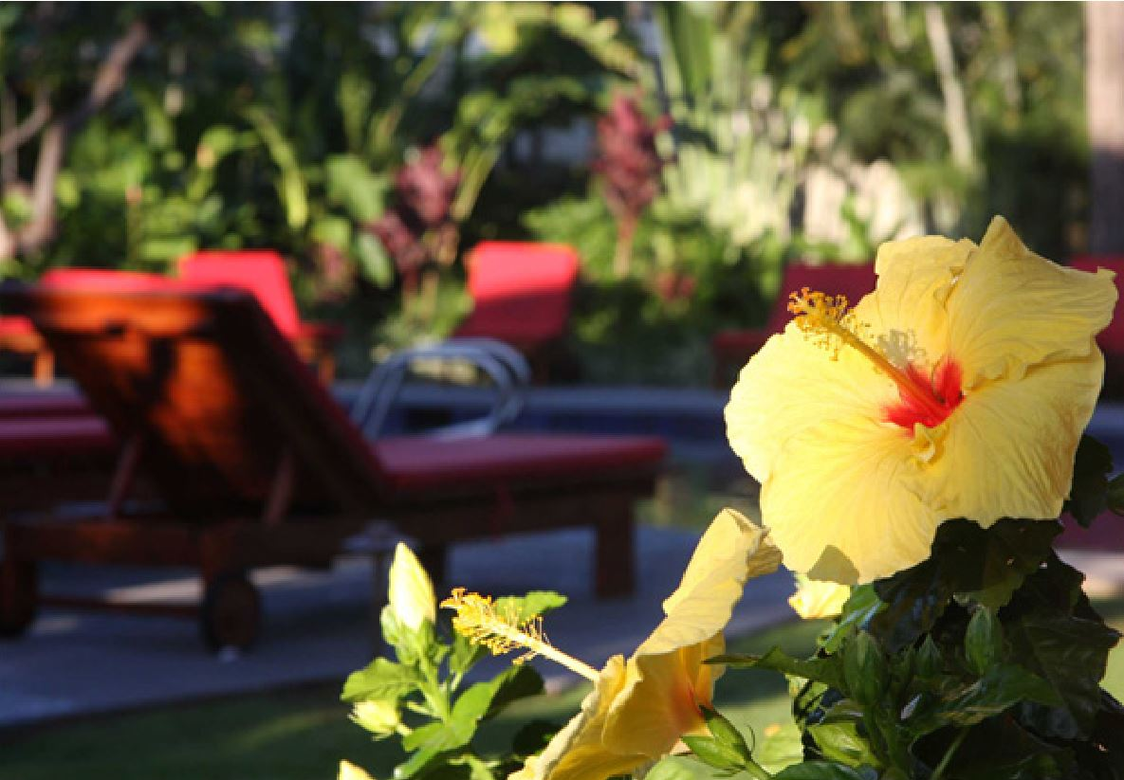
Thank you for choosing to stay in our condo in Kihei. We love Maui and have put together this guide to share some of the things we love best with you.
Enjoy!

The Ritscher-Osorio Family
www.MauiParadiseRentals.com

Table of Contents:
- Contact Information
- Transportation
- The Island
- Things to do in Kihei and Maui
- Beaches
- Nightlife
- Restaurants

Contact Information
Return to table of contents
We hope you enjoy our little piece of paradise as much as we do. When you arrive, please take a moment to look over the condo and let us know if anything is not to your satisfaction. Please also take a moment to look through this binder which includes useful information about the resort and the area. Please keep in mind this is a privately owned condo and the front desk will not be able to assist you doing your stay. We can be reached by phone or email at any time if you need anything during your stay.

Please call or text us at:
April 1-206-949-5758

Or email us at:
info@MauiParadiseRentals.com

Follow us on these social networks for updates:
Facebook - https://www.facebook.com/LahainaRental
Twitter - https://twitter.com/LahainaRental
Pinterest - http://www.pinterest.com/lahainarental/

Transportation
Return to table of contents
Renting a car
All the major rental car companies are near the airport. Advantage Rent a Car http://www.advantage.com/ is normally the most cost effective rental.

Most of the rental car agencies also have locations in Kihei (Avis, Dollar, Enterprise, etc.)

Taxi Services
Lyft and Uber are also on the island now and are comparable in prices to a shared shuttle- Download the app on your phone to book your ride.
24 Hour Taxi Service on Maui (808) 243-TAXI (808) 243-8294
Serving: Wailea, Kihei, Wailuku, Kahalui, Paia, Makawao, Haiku, Lahaina, Kaanapali, AIRPORT, and ALL of Maui
Available 7 Days a Week/24 Hours a Day
Visa & Master Card Credit Cards accepted
Kihei Taxi (808) 298-1877
Serving: ALL of Maui
Email: info@kihetaxi.com
Credit Cards accepted
Star Maui Limousine (877) 875-6900 (808) 875-6900 http://www.limohawaii.com/
Email: info@limohawaii.com

Shuttle Services
Maui Airport Taxi and Shuttle (808)877-2022
http://mauiairporttaxi-shuttle.com/

Speedi Shuttle (877)242-5777
http://www.speedishuttle.com/

Roberts Shuttle (808) 439-8800
https://www.robertshawaii.com/airport-shuttle/maui/

Public Bus Transit System

Maui Bus Service (808) 871-4838

Website: http://www.co.maui.hi.us/index.aspx?NID=1310

(Bus times and routes)

Fees - Effective July 1, 2018 (Check for latest fare information.)
The fare is $2.00 per boarding. Daily and monthly passes are also available.
Daily Pass $4.00.
No transfers are given on any of the routes.

The Maui Bus public transit service consists of thirteen (13) bus routes, all operated by Roberts Hawaii. These routes are funded by the County of Maui and provide service in and between various Central, South, West, Haiku, Kula and Upcountry Maui communities.
All of the routes are operated seven days a week, including all holidays. No transfers are given on any of the routes. All vehicles on the routes are ADA accessible.

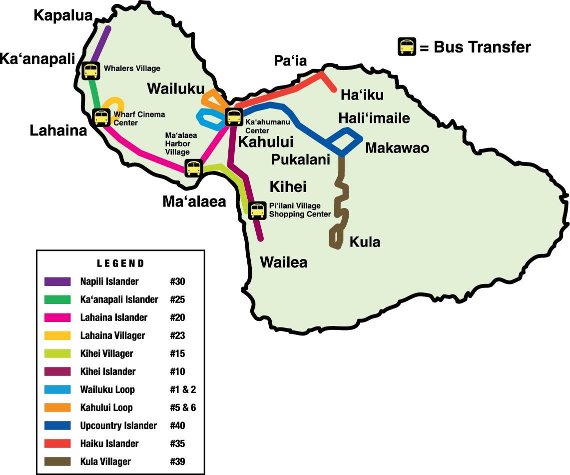

The Island
Return to table of contents

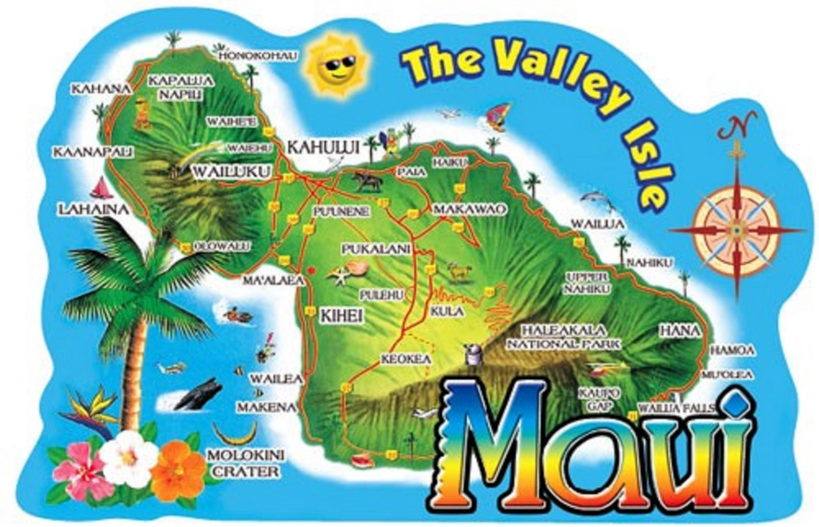
Legends say the demigod Maui pulled the Hawaiian Islands from the sea and lassoed the sun atop Haleakala, the island’s highest peak. The island of Maui was named after this mythological being, perhaps because the shape of the island is said to resemble his head and body.
King Piilani was the first ruler to unite all of Maui under a single family of alii (royalty) in the early 15th century. In 1790, King Kamehameha I defeated Kahekili, Maui’s last king, after a fierce battle in the iconic Iao Valley. Kamehameha took control of Maui and made Lahaina the new capital of the unified Hawaiian Kingdom. For nearly five decades, Lahaina served as the center of government for Hawaii. Simultaneously, the town experienced a surge in its whaling industry. At the height of the whaling era (1840-1865) as many as 500 ships anchored in Lahaina’s port.
Maui’s first sugar mill began operations in 1828. As the sugar industry in the islands grew, an influx of plantation workers from China, Japan, Puerto Rico, Korea, the Philippines, Portugal and Europe arrived in Hawaii. These immigrants became the foundation of the multi-ethnic culture of Hawaii today. You can experience these influences at places like the Lahaina Jodo Mission and in the fusion of flavors found in Hawaii Regional Cuisine.
The Lahaina Historic Trail and other notable attractions allow you to explore Maui’s rich past today, adding a fascinating new dimension to your visit.
www.gohawaii.com/maui/about/history

Central Maui
Home to much of the island’s population, this area offers plenty of interesting attractions and off-the-beaten-path treasures to uncover. The top attraction in Central Maui is peaceful Iao Valley State Park, with fog-shrouded forests, lush valleys and burbling streams. Take an easy hike on a paved trail to view one of Maui’s most iconic landmarks, the 1,200-foot Iao Needle. At the gateway to Iao Valley State Park, you can browse local shops, restaurants and historic sites in the charming town of Wailuku. The neighboring town of Kahului is a bustling shopping district with Maui’s largest mall, and if you want to stock up for an epic trip, everything you need can be found here.
East Maui
When your mind imagines Maui, it probably looks a lot like the island’s epic east side: cascading waterfall pools hidden in lush rainforests, roadside pineapple stands, hairpin turns around plunging sea cliffs. It’s all here, along the legendary Road to Hana—one big reason why East Maui is a must-see on any traveler’s list.
South Maui
You’ll find the sunniest, driest area of Maui on the peaceful southwestern coast. Blessed with miles of sandy beaches and clear views of the islands of Lanai, Molokini and Kahoolawe, South Maui is a place for lazy days and romantic nights. Explore the immersive underwater aquarium at the Maui Ocean Center in the whale-friendly Maalaea Bay. Golf at world-class courses in Wailea. Shop and dine in some of Maui’s finest restaurants and resorts. Discover Maui’s warm hospitality on its spectacular southern coast.
West Maui
The sunny northwest coast of Maui was once a retreat for Hawaiian royalty and the capitol of the Hawaiian Kingdom. Today, West Maui is home to spectacular resorts, shopping, restaurants, a wealth of activities and some of the most amazing sunsets in the world. Traveling north from Maalaea and the Maui Ocean Center, your first stop is the historic whaling town of Lahaina. Rustic buildings recall its days as Hawaii’s busiest port, while bustling shops on Front Street and winter whale watching make it a favorite port of call for cruise ship passengers. A few minutes more on the Highway and you’ll find yourself drawn into the vibrant Whalers village. Whether you’re staying in the area or just passing through, a stroll on the Kaanapali Beachwalk is always in order. Families play on the beach, shoppers buzz in and out, and diners sit back and simply soak in the view. Further up is Kapalua, known for championship golf and private getaways. Here, the tone is a bit quieter, with understated elegance.
Upcountry Maui
Golden beaches give way to rolling hills and misty mountains as you ascend into Upcountry Maui, which is located on the higher elevations surrounding Haleakala — the island’s highest peak. Since early times, Hawaiians have farmed the volcanic soil of Upcountry fields, growing taro and sweet potato. Today, you can take farm tours, visit a goat dairy or even sip Maui-made wines and spirits in the rustic outposts of Kula and Makawao.

Beaches
Return to table of contents

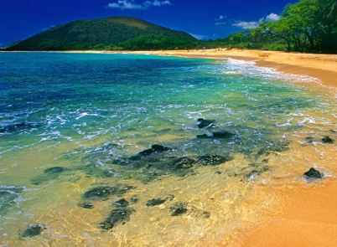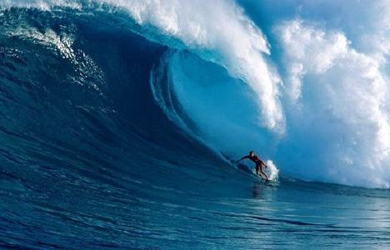

Within walking distance

Kamaole Beach Park 1-3
Kamaole Beach Park is Kihei's best beach! (Kam as the locals lovingly refer to it) is located right across the street and is part of the triad of beaches known as Kamaole Beach Parks #1, #2 and #3. This is the part of the southern coastline of Maui that starts to have the exotic and beautiful white sand beaches that Kihei and further south Wailea and Makena are famous for. Kamaole 2 is a beautiful white sand crescent that stretches one-third of a mile from one point to the other. Snorkeling is really only good here at the points of the beach but the white sand bottom in the middle makes an ideal place to swim.

As far as amenities Kamaole has a parking lot as well as parking available along Kihei Rd and in a dirt parking lot on the other side of the street. A nice access point is the North side of the beach at Charlie Young. Restroom, showers, picnic tables and some barbecue stations are available. There is often a volley ball net set up in a sandy portion of the park. A lifeguard station is available.

Cove Park
Cove Park located just North of Kam 1, has a small sandy beach and is a nice spot to just hang out, read a book and enjoy the surroundings. The ocean is usually the clearest in the early mornings and in the winter months (November to March) due to ocean currents.
Cove Park is also a good paddle boarding and surfing beach, and surf lessons are given here. There are no lifeguards and no facilities, so bring supplies.
Across the street is Maui Wave Riders that rent paddleboards and surf boards and can also provide lessons.

Kalama Beach Park (Puunoa Beach)

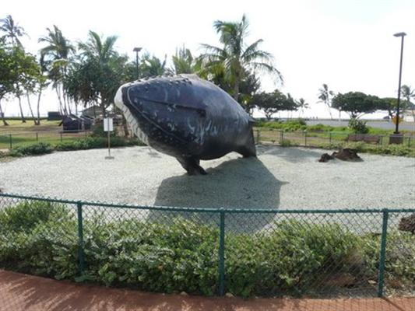
Kalama Park, a 36 acre beach park, is a spacious and diverse park complex suitable for organized sporting events, outdoor concerts, fairs, festivals and gatherings of all kinds. Although the beach is very small here, the park provides excellent facilities for picnicking and family outings. Sunsets are spectacular from this park and quite a gathering spot during that time of the day as everyone awaits.
Services and Amenities
No lifeguard
Restrooms
Telephones
Picnic tables and pavilions
Showers
BBQ grills
Grassy areas
Small beach area
Rocky shoreline with a small beach

Skateboard Park and inline skating rink (lighted in the evening)
Sport areas for volleyball, basketball, baseball, soccer and tennis. Tennis courts are lighted in the evening.
A little further out

Wailea Beach
Wailea Beach is located toward the southernmost part of Kihei Maui. It is a large beach, crescent in shape, capped on either point by black, lava rock formations. This lends to the calmness of the waters, making this an ideal place for swimming, snorkeling, and sunbathing. Changing rooms, showers, eateries, and places to rent gear and equipment are available. There are lifeguards on duty. You will also find a large paved walkway leading to a variety hotels, restaurants, shopping and entertainment.

Makena Beach State Park (Big Beach)
One of Maui's signature beaches and is at the top of the list of beaches not to miss. With white sands extending nearly 2/3 of a mile long, is one of the largest beaches in Maui. Boogie boarding is very fun at this beach, but the waves can get a little big in the late afternoon.

Keawakapu Beach
Situated between Kihei and Wailea to the south, Keawakapu Beach is one of the most picturesque stretches of coast in southwest Maui. This beach is rarely ever overcrowded, as there are no major resorts or hotels. The surf is always calm and the white sand and shady palms make the deal even sweeter. There are no lifeguards on duty, but you can find some places to rent equipment like umbrellas and chairs nearby.

Ka’anapali Beach
Beautiful golden sand and crystal clear water make this a very popular beach. One of Maui’s best beaches is Kaanapali Beach, with three miles of sandy shores to enjoy. The northernmost section of the beach is a great place for snorkeling where you can see the different creatures living in the area up close and personal. As one of the signatures of Kaanapali, cliff-divers love to jump off the beach’s northernmost edge, Puu Kekaa, or Black Rock. The ceremony occurs every evening at sunset to honor King Kahekili. Watch divers light the torches on top of the cliffs before they leap into the waters below. It is a spectacle you won’t want to miss! Parking is expensive but your cheapest option is typically Whalers village. You can also take the bus and not worry about parking. Black Rock is located in front of the Sheraton Resort.

DT Fleming Beach Park
Voted best beach in America in 2006. Facilities include picnic tables, restrooms, showers and lifeguards. The beach backs up to a grove of trees providing much needed shade.

Ho'okipa Beach, North Maui
The best place in the world to watch windsurfers at what is known as the "windsurfing capital of the world." You'll also see some great board surfing here towards the east end of the beach.
Ho'okipa Beach is also a great place to see turtles coming up on the beach (this is not in any of the guide books). They starting coming up approximately 1 hour before sunset. The gate closes at 7pm, so make sure you leave the park by then.

Kahana Beach
If you’ve ever had an interest in windsurfing, Kahana Beach is the place for you, as if offers excellent windsurfing conditions. There are lifeguards on duty so safety won’t be an issue. The beach also features convenient restrooms and showers for a quick change as well as picnic tables so you can enjoy a meal as you gaze out onto the ocean.
Hana Beach Park
For a terrific family-friendly beach day, you won’t want to miss out on Hana Beach Park. This is another one of the most popular swimming beaches on the island. There are also many local community events held at this beach, so check one out to see how the locals enjoy themselves.

Kaihalulu Beach
Maui’s red sand stretch of sand. It was the site of a fortress and temple and birthplace of civil leader Queen Ka’ahumanu. Kaihalulu is one of the new red sand beaches in the world, made so by the abundance of iron, and with the rich contrast against the blue waters.
Snorkeling
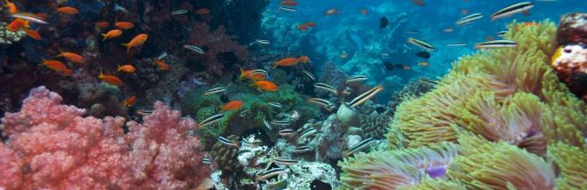
There are many great snorkeling places on Maui Ask for a free snorkel map at Maui Dive Shop or call them at 1-800-542-3483, or check out their web site at www.mauidiveshop.com.

Some of our favorites are:
Ulua
Located between the Renaissance and the Wailea Marriott, both Ulua and Mokapu are popular places to snorkel and shore dive. This is a wonderful beach for snorkeling (one of our favorites) and diving when it is calm and just for hanging out. It is easy sandy beach for good access especially with children. Snorkeling is best at the right (north) side of the beach near the rocky outcrop. Swimming and snorkeling are best in the mornings (afternoons can be windy here, making the ocean choppy and the visibility poor). When surf is up, beach attracts body boarders. This is Maui's South shore training area for many scuba school's beginner dives. There are two reefs found stringed between the two beaches. The first one is great for snorkeling, and scuba divers best access the second one. The second reef is deeper and has a turtle cleaning station. Backed by a small park, ideal for picnics. Arrive early, parking lot fills up quickly.

Makena Landing
Makena landing, aka Five Caves aka Five Graves, is a wonderful spot to snorkel or dive. The topography here is diverse and sea caves plenty. This area is home to many small harmless reef sharks. Make sure to only snorkel here if there have been no rains or large surf due to the impairment of visibility. This area has plenty of parking and many entrance points.

Ahihi Keanau Reserve
Ahihi Keanau Reserve is located in Makena and one of the more serene and beautiful spots on the island. Parking is a challenge in this area though. The road is narrow which has only a few openings for a car. The reef is shallow and perfect for snorkeling. This isn't the best Maui scuba diving location because it's so shallow; you'd rather be snorkeling, unless you travel far out. The coral here is plentiful and comes in many brilliant colors. Keep in mind that this is reserve, which is why there are so many fish here. The fish are protected! If you want to do some Wailea fishing, charter a boat and stay out of this area.
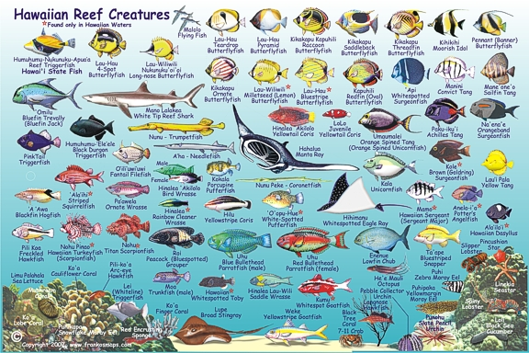

Things to do in Kihei and Maui

Surfing and standup paddle boarding
Maui Wave Riders 2021 S. Kihei Rd, Kihei (808) 875-4761 www.mauiwaverriders.com
Big Kahuna Adventures 1913 S. Kihei Rd #C, Kihei (808) 875-6395 www.bigkahunaadventures.com

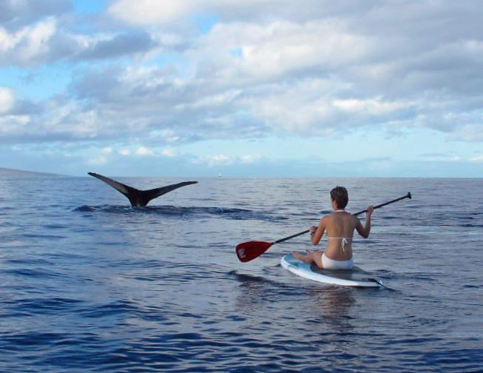

Walks
Kihei Coastal Trail
Follow this trail along coastal bluffs ideal for whale watching and quiet meditation. At the start of the trail look for the burrows of ʻuaʻu kani (wedge-tailed shearwaters), ground-nesting seabirds that return to the same sites each spring. The birds lay a single egg and remain until November, when the fledglings are large enough to head out to sea.
The trail starts beyond the grassy lawn at the south end of Kamaʻole Beach Park III and winds half a mile south to Kihei surfside condos, just beyond Kihei Boat Ramp. The path is made of packed gray gravel outlined in white coral. Curiously, when the trail was being built, a storm washed hundreds of yards of bleached coral onto the shore here. The coral was not originally planned for the trail construction, but the volunteers building the trail consulted with a Hawaiian kahuna (priest) and were told ancient trails were often outlined in white coral so they could be followed at night. The Hawaiian gods were thanked for the gift of coral, which was then incorporated into the trail.

Wailea Beach Walk
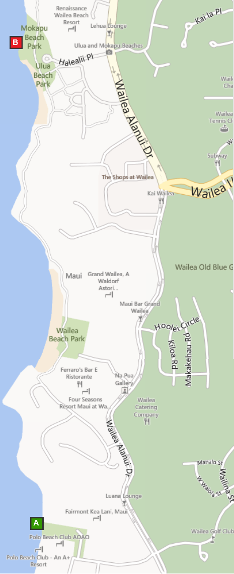
(Up to 4.25 miles roundtrip)
Walk and jog along Wailea Beach Walk, which stretches from The Fairmont Kea Lani, Maui all the way north to the Andaz Maui. A paved, wheelchair-accessible coastal path winds past Wailea’s beach resorts and five beaches, facing some of South Maui’s best beaches.
In the morning, there is a Whale's Tale Juice Bar in the old Lauhala Hut oceanfront at Wailea Beach Marriott Resort & Spa. From 6:30 a.m. to noon daily, the Whale's Tale team blends fresh tropical juices, pours Starbucks coffees and dishes up breakfast fare.
In the evening, you can watch sunset and listen to some of the hula performances and Hawaiian music and, or try spotting whales offshore during winter.
Directions & Parking
To get to the South Access point “A on the map”: From the resort, go out to the main road, Kihei Road and turn left.
Continue on Kihei Road. Slight left onto Okolani Drive for 0.3 miles. Turn right onto Wailea Alanui Drive for 1.7 miles. Turn right on Wailea Ike Drive To Polo Beach (south access). Turn right on Kaukahi St, just past the Farimont Kea Lana, and follow signs to Polo Beach Shoreline Access.
Parking
To park for FREE, there is a county park back by the Polo Beach club at Polo Beach, turn beside the Kea Lani. Parking, restrooms, picnic table. This is the south end of the Beachwalk.

Yoga Classes
Maui Massage and Yoga 2450 S Kihei Rd, Kihei (808) 214-0129 www.johannawaters.com
Try yoga on the beach.
Massage Maui 145 North Kihei Road, Kihei (808) 357-7317 www.massage-maui.com
Kihei Yoga 1847 S Kihei Rd #103, Kihei (808) 269-2794 www.kiheiyoga.com

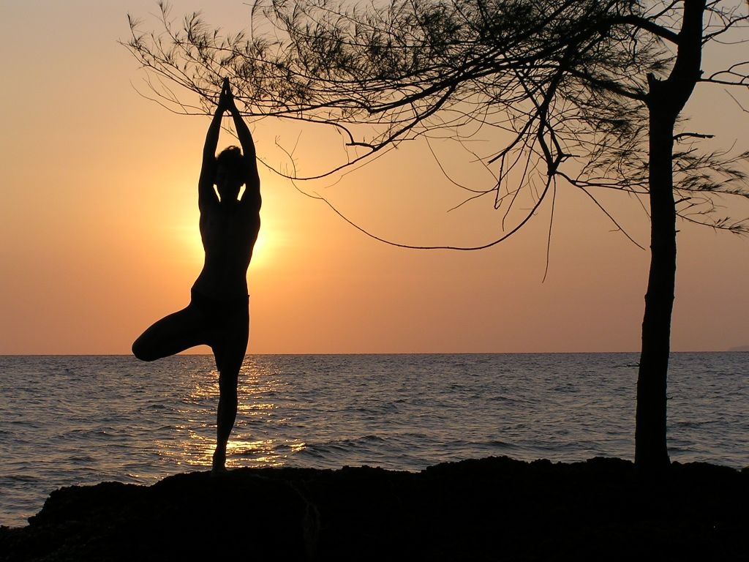

Kihei Aquatic Center 303 E. Lipoa St, Kihei (808) 270-8208 www.co.maui.hi.us/Facilities/Facility/Details/20

Maui Boat Rentals (808) 879-3721 www.maui-boat-rental.com Email: reservations@maui-boat-rental.com

Maui Friday Town Parties
Maui Friday Town Parties is an initiative to showcase our island’s historic towns and celebrate the unique nature of the businesses in the communities. From Market Street to Front Street, from Baldwin Avenue to South Kīhei Road most every Friday our community gathers to celebrate art, music and Maui culture. Residents and visitors enjoy a special night of interaction and fun, punctuated with free entertainment, special offerings and Friday-only promotions from each town’s family of merchants.
What is the Maui Friday Town Party schedule?
- First Friday of the month – Wailuku
- Second Friday – Lahaina
- Third Friday – Makawao
- Fourth Friday – Kihei
What can I expect at a Maui Friday Town Party? Generally from 6-9pm, Maui Friday Town Parties are a safe, fun community-minded way for both residents and visitors to kick-off the weekend under the stars and enjoy our small-town ambiance. Many retailers, galleries and boutiques operate extended hours and highlight special promotions. Crafters, artisans and culinary wizards add their creativity to the event. Attendees have fun while simultaneously supporting our economy and revitalizing historic Maui.
Lahaina Town and Banyan Tree
Visit Lahaina for a fun day of shopping. Lahaina is a cute little walking town with tons of shops and restaurants along Front Street. The Banyan tree was planted in April 1873 and now covers almost an acre! On Saturday mornings, local artists set up stands under the tree to showcase their wares. If you appreciate art, check out the Lahaina Art walk every Friday night between 6:30-9:30 p.m. Dozens of art galleries along Front Street showcase their art along with wine and appetizers.

Excursions
Whether you want to fish, cruise, snorkel, scuba or just sail around, a majority of the excursions on island depart from the Makena, Maalaea, and/or Lahaina Harbor. Most of the companies have booths set up in the harbor and you can shop around for prices. There are also quite a few timeshare companies that offer discounted excursions or meals if you sit through a timeshare sales appointment. If you don’t mind investing a few hours of your time and are good at saying “No”, this can be a good way to reduce the cost of some of the excursions. Keep in mind, most of the timeshare sellers, will give you more than one discounted excursion with each timeshare presentation.
Whale Watching
The waters surrounding Maui are the stage for some of the best whale watching in the world. Each winter thousands of kohola (humpback whales) travel to Hawaii from colder waters to breed, calve and nurse their young. Although the first whale sightings will usually occur sometime in October, whale season officially runs from December 15-May 15. Since activity tapers towards the end of the season, however, most Maui whale watches stop running sometime towards the end of April. There are dozens of companies offering whale watching tours leaving from the Lahaina, but our favorite are the ones ran by the Pacific Whale foundation.

Further out
Road to Hana (Full Day)
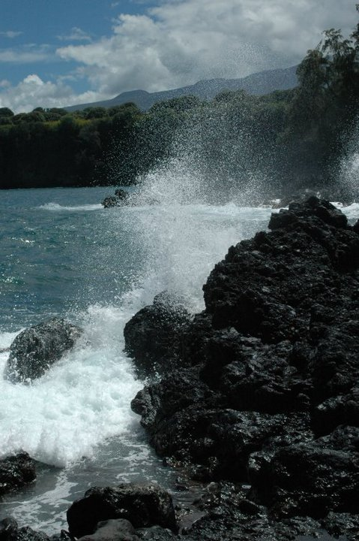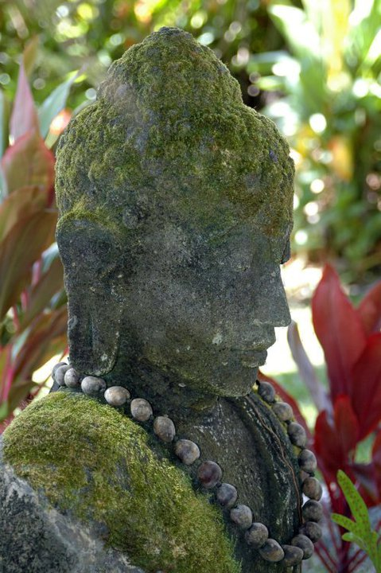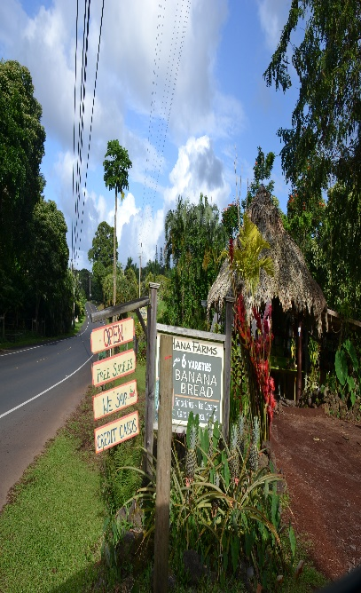
You can drive the road to Hana yourself, or take a tour in a van. It is a long and difficult drive on a narrow winding mountain road. If you prefer to have a tour van take you, you can sign up for a tour. Whether on your own or on a tour, you will see the gorgeous scenery of the rainforest, including many beautiful waterfalls of various shapes and sizes along the mountainsides. If you drive yourself, leave early (7 A.M) and take a picnic lunch. Allow six hours to get to Hana (with stops to see scenery), and three hours to return (without stops). It's 72 miles from the condo; the hard part (the Hana Road) has 617 curves and 56 one-lane bridges. If you are prone to motion sickness, do not read (not even the map) in your car or tour van. If you drive to Hana (rather than taking a van tour), be sure to take along the "Hana CD Guide. This is an audio CD that tells you what to see along the way. You play the CD in your car while you drive to Hana. You will see twice as many wonderful sights if you take this guide recording along plus the narrators are pretty entertaining.
Paia is the last town that you will pass before your make your journey to Hana. It is a great place to eat breakfast, grab some cofee or pick up a Hana picnic boxed lunch. Our favorite place is the one on the left, next to the bike shop. It is also a good idea to stop and use the restroom here as there are few restrooms along the rest of the route.

At mile marker 2, Twin falls is the first waterfalls along the Road to Hana with easy access. There is a farm stand selling yummy smoothies and there will be a bunch of parked cars. The hike to see Twin Falls is unique and beautiful. These picturesque waterfalls offer a large area to swim at. Consider sticking to the closest falls along the path (lower falls) in order to save time on your trip and be really careful of flash floods!

From the bluff, Ho'okipa( at mile marker 9) is a great spot to stop and watch some of the best surfing in Maui. In the winter, the waves can get pretty massive here. Maui is Mecca to windsurfers and Kiteboarders due to consistent wind. DO NOT SURF HERE unless you are very experienced and are able to go with a local. At mile marker 9.5 there is Waikamoi Ridge Trial which has 2 hiking loops.One takes about 10 minutes and the other takes about half an hour. Waikamoi Trail can sometimes be muddy, but it's a pretty hike through the trees.

Remember the beauty of the road to Hana is the route itself, not the destination. Make sure you stop to enjoy the scenery and take lots of photos! The Garden of Eden is a beautiful place to stop for a picnic and enjoy your boxed lunch. It’s located at mile marker 10.5. They are open 8 am-3 pm and the entrance fee of $15 dollars per person. It's worth paying to enjoy walking the grounds, which are immaculately kept up and offer all kinds of photo opportunities. Here you can see and 100 year-old mango tree, bamboo, ocean views and Puohokamoa Falls. You may recognize some of the views here as they were featured in Jurassic park!

At mile marker 12 is Kaumahina state waside park. There is a beautifual view of the North coast plus real bathrooms, which are a rarity on the road to Hana. There are also hiking trails through the forest.

On the way to Hana, just past Mile Marker 16, turn left at the sign to Keanae, for close-up views of waves on lava rocks. Stop near the end of that peninsula to pick up a couple loaves of the world’s best banana bread, at the Keanae Landing Fruit Stand.

At mile marker 19 you will find Upper Waikani Falls AKA 3 Bears, there's enough room for 2-3 cars, but it's a no parking zone. Once a few cars park, 6-7 more park behind it and take up most of the road becoming a hazard. There is, however, a turnout further up the road where you can park and walk down. The walk is a little hairy because there isn't a path.

At mile marker 22 is Pua’a Kaa State Park. This rest stop offers a quick hike to a waterfall and a freshwater pool as well as bathrooms and picnic area. A great place to stretch your legs and get a quick swim.

At mile marker 29 is Nahiku MarketPlace. This is a fun spot to pick up some gifts and have a great meal. They have some of the better kalua pork tacos we've ever had.

At around the 31 mile marker, you'll need to turn left on 'Ula'ino Road. Less than a 1/2 a mile on the left, there is a massive lava tube. Also, they have a garden maze that's fun to cruise through. Drive a bit further and on the right you'll see the National Tropical Botanical Gardens. They have the only accessible view of Pi'ilanihale Heiau, which is the largest Temple in Hawaii.

Despite its size, Hana is packed with plenty to do. Snorkel at the breathtaking black sand beach of Waianapanapa State Park, or swing by Hale Piilani, which is the state’s biggest temple. Bring the kids for a day of swimming and layin’ low at Hana Beach Park.

If you have extra time, you can drive another 40 minutes beyond Hana to the beautiful Pools of Ohe’o, also called Ohe’o Gulch and Palikea Stream. (This area was formerly called the Seven Sacred Pools). There are several lovely waterfalls cascading into the series of natural pools, working their way down the mountain slope. Our favorite thing to do is the hike up alongside the pools to the top. There is a beautiful bamboo forests along the way. It is approximately 2 hours round trip.
A little further beyond here is Charles Lindbergh’s grave at Palapalo Hoomau Church, but it is not visible from the road and is bit difficult to find.
Haleakala National Park
Haleakala (elevation 10,023 feet) is the mountain that makes up the entire east half of Maui. The crater at the top of this volcano is one of Maui’s most incredible sights. The view at the top of Haleakala is beautiful at any time of the day, so you don’t have to go only at sunrise but this is when most people go. You'll see the multicolored volcano crater (that last erupted in 1790) and the views of Maui's central valley. It is much colder at this elevation than at the beach, so bring a jacket.Park admission is $10 per car. Keep your receipt as you can use this to park at the bamboo forest too! Free ranger nature talks in the summit building are offered. The crater is seven and a half miles long, two and a half miles wide and 3000 feet deep. You will look down on the clouds, and see the "Big Island" of Hawaii in the distance across the ocean. (The left mountain is Mauna Kea 80 miles away, and the right mountain is Mauna Loa 100 miles away). We recommend leaving the condo by 4 a.m. It takes almost two hours to get there. Due to its popularity, you now need a reservation to see sunrise. For more info, go to
https://www.recreation.gov/tourParkDetail.do?contractCode=NRSO&parkId=147940

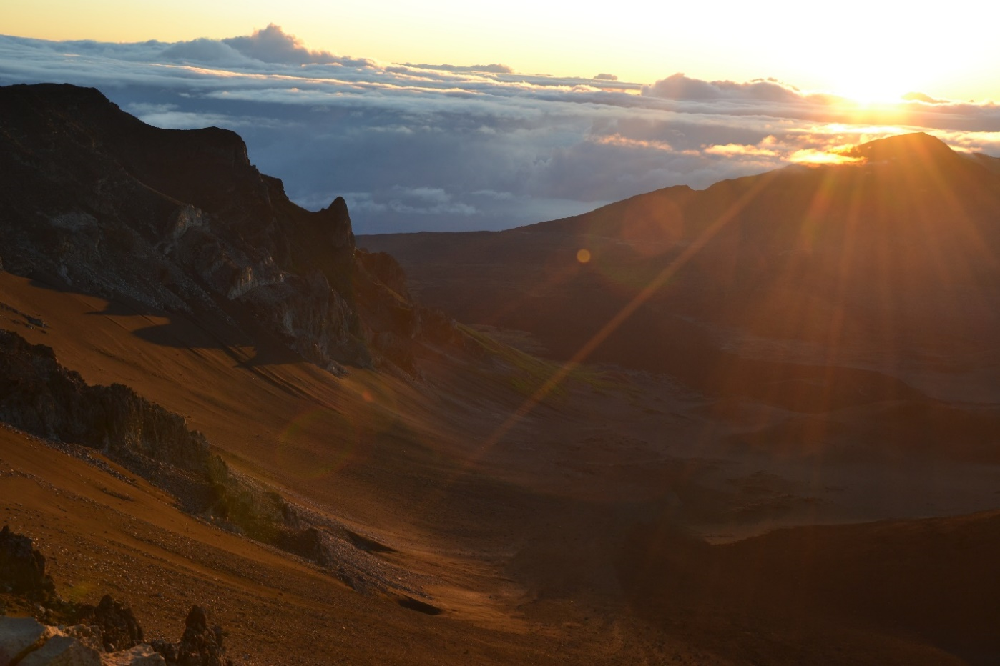

Botanical Gardens
Kepaniwai Heritage Gardens Park Bring the whole family to Kepaniwai Heritage Gardens Park to learn about the island’s cultural and ethnic heritage. As you move through the park you’ll see a traditional Hawaiian hale, a New England-style missionary home, Japanese gardens with stone pagodas, a Filipino farmer’s hut and a Chinese pavillion with a statue of Sun Yat-sen, a revolutionary hero.You and your family can enjoy a lovely meal together in the park’s picnic area surrounded by natural beauty. The park also features the Hawaii Nature Center, where kids can experience exhibits geared toward them. The center also offers two-hour rainforest walks.
Arts, Cultural Centers, Museums
Whalers Village Museum For a top-notch Humpback Whale education, stop at the Whalers Village Museum. Volunteers here can answer any questions about the animals. The 40-foot sperm whale skeleton located near the entrance is sure to impress, and it sets the scene for a trip inside in the museum. Learn about the history of whaling on the island and check out collection of harpoons, tools, sea chests, sailor journals and ship logs. Take a self-guided audio tour in many different languages as you look at artifacts, photo murals, movies and graphics depicting the life of sailors. You can even see a scale model of a whaling ship with an exact replica of the living quarters of a 25-member whaling crew.
Maui Arts and Cultural Center To get a taste of Maui’s culture, head to the Maui Arts and Culture Center, a performing arts complex. Check out live music, an art exhibit or a variety of other events that celebrate creativity in its theaters, outdoor performance space, gallery concert stage and courtyard with bistro dining and food and beverage bars.
Maui Ocean Center (Aquarium) 192 Ma'alaea Rd, Wailuku (808) 270-7000
http://www.mauioceancenter.com

Wine Tasting
Tedeschi Vineyards (808)878-6058 www.mauiwine.com
Free tour of Maui's only winery and free wine tasting in Upcountry.

Local Golfing
5 minute drive
Elleair Maui Golf Club (808) 874-0777
18 holes, par 71, 6801 yards. All prices per person and include golf cart rental.
1345 Piilani Highway, Kihei, HI 96753

10-15 minute drive
Makena Golf Course 5400 Makena Alanui, Wailea-Makena (808)891-4024
18 holes, par 72, 7017 yards. All prices per person and include golf cart rental.
Wailea Emerald & Gold Golf Club 100 Wailea Golf Club Drive, Wailea (808) 875-7450
18 holes, par 72, 6825 yards & 7078 yards. All prices per person and include golf cart rental.
Wailea Old Blue Golf Course 120 Kaukahi Street, Wailea (808) 879-2530
18 holes, par 72, 6765 yards. All prices per person and include golf cart rental.

35 minute drive
Pukalani Country Club 360 Pukalani Street, Pukalani (808) 572-1314
18 holes, par 72, 6882 yards. All prices per person and include golf cart rental.

45 minute drive
Royal Kaanapali Golf Course If you like to hit a round of golf, don’t miss the world-class courses at Royal Kaanapali, designed by Robert Trent Jones Sr., and Kaanapali Kai. Both offer pristine fairways and Bermuda grass on the greens, yet the 18th on the Royal can be a real doozy. Royal is often referred to as the Tournament Course, since it hosted the LPGA and Senior Tours during the 1980s.

Shopping

Natural Food Markets
Stores in Kihei
Hawaiian Moons Natural Foods 2411 S Kihei Rd Ste B1, Kihei · (808) 875-4356
Safeway 277 Piikea Ave, Kihei · (808) 891-9120
Turn Right on Kihei Rd. Turn right on Piikea Ave.
Foodland 1881 S Kihei Rd, Kihei · (808) 879-9350
Open 24 hours.
Times Supermarket: 1310 S Kihei Rd, Kihei · (808) 879-5871
Short Drive. Turn Right on Kihei Rd. It will be on your left.

Others Natural Food Markets around the island
Mana Foods: 49 Baldwin Avenue, Paia. This is one of our favorite grocery stores to shop!
Down to Earth: Kahului
Whole Foods Market: Kahului
Foodland: Pukalani, Lahaina, Kahului
Pukalani Superette: Pukalani
Foodland Farms: Lahaina
Haiku Grocery: Haiku
Rodeo General Store: Makawao
Cash n Carry Warehouse: Kahului
Aina Gourmet: Lahaina
Times Supermarket: Lahaina
Safeway: Kahului, Lahaina

Farmers Markets (Fruit and Vegetable Stands)

Rowena’s Farmers Market
Located at the end of Kupuna St towards the beach
During certain days of the week, there are other farmers that also sell their fruit and vegetables here.
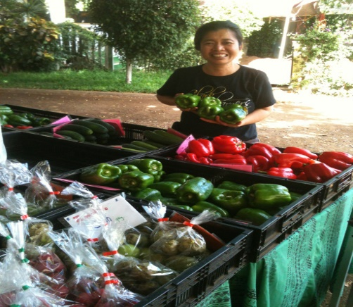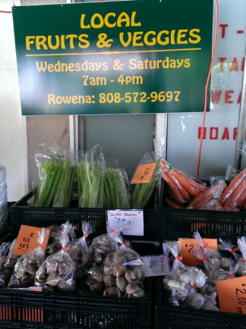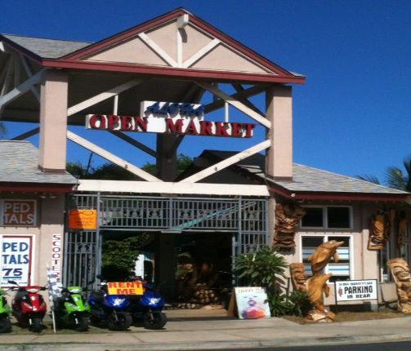
South Maui (Kihei-Wailea side):
Farmers' Market of Maui-Kihei 61 Kihei Rd, Kihei
Monday thru Friday, 8 am -4pm
Lipoa Street Farmers Market 95 Lipoa St, Kihei
Saturdays 8 am-12 noon
West Maui (Lahaina-Kaanapali-Kapalua side):
Farmers' Market of Maui-Honokowai 3636 Lower Honoapiilani Rd, Honokowai
Monday Wednesday Friday, 7am-11am
Central Maui and Upcountry (Kahului-Wailea and Kula areas):
Maui Swap Meet Maui College in Kahului
Saturdays, 7am-1pm (A favorite of ours)
Kula Country Farms Kula Hwy at Kekaulike
Saturdays & Sundays, 11am-4pm
Upcountry Farmer's Market 55 Kiopaa in Pukalani
Saturdays, 7am-12 pm

Services
Kihei Barber Shop (808) 874-3994

Souvenirs
Kihei Kalama Village is across Kalama Park. This is a nice place to shop for souvenirs such as fossilized sharks teeth and fresh leis. With a bit of a "bizarre" feel to it, the Kihei Kalama Village shopping complex is one of the best arts and crafts locations on the island of Maui. While some of the items for sale can be found in other stores, generally the prices here will be much cheaper. Open 10 am to 7:30 pm.

Places with free printing (For boarding passes etc)
Maui Banyan front lobby- There is a computer for guests use.
Café La Plage (in front of Kamaole Beach I) 2395 S. Kihei Road #115 Kihei (808) 875-7668
http://cafe-maui.com/
Located in Dolphin Plaza across from Kama’ole Beach Park One
The UPS Store 1215 S. Kihei Road STE O KIHEI, HI 96753 (808) 874-5556
Monday – Friday 8:00 am - 6:00 pm
Saturday 9:00 am - 5:00 pm
Sunday Closed

Bus:
Line 10, stop at Kamaole Beach I‎
Click for bus schedules

Stores at Kihei Kalama Village
808 Clothing Co. (808) 891-8388  www.808clothing.com  Aloha Essence of Maui (808) 879-3004  Beach Bumz (808) 875-8751  Blue Diamond Arts  Clementine's (808) 875-4449  Da Beach House (808) 891-1234:  www.dabeachhousemaui.com  HJM Gift Shop (808) 574-8483  Honu Maui's Gift Store (808) 891-8091  Island Chong Fashion (808) 879-3093  Ipo Boutique (808) 879-3733  Jade's Aloha Souvenirs: (808) 875-9585  Kai Jewelry (808) 879-1331  Keilana  Kihei Creations (808) 891-0798  Kontiki (808) 891-0005 | The Love Shack Maui (808) 875-0303  www.loveshackmaui.com  Mahina (808) 879-3453 www.mahinamaui.com  Maui Aloha Wear (808) 874-8972  Maui Envy (808) 875-7007  Maui Pearl (808) 891-0798  Namuu Wraps (808) 875-0606  Nani Pacifica (808) 281-6040  Omar's Art & Crafts, Bead & Gift Shop (808) 891-0003  Seasteps (808) 875-8434  Serendipity (808) 874-8471: www.serendipitymaui.com  Shari's Island Wear & Gifts (808) 891-2505  Sun Shop (808) 875-8463  Tutu's Pantry (808) 874-6400 www.tutuspantry.com  Y & J Gifts (808) 891-0990

Nightlife
Return to table of contents

Luau’s (close by)
There are many luaus to choose in Maui. The closest are in Wailea.
Te Au Moana Luau 3700 Wailea Alanui, Wailea 877-827-2740; http://www.teaumoana.com/
Wailea Beach Marriot Resort and Spa,
The Grand Luau at Honuaula 3850 Wailea Alanui, Wailea 808-875-1234
The Grand Wailea

Luau’s (Further out-45 minute drive)
Old Lahaina Luau 1251 Front St, Lahaina (808) 667-1998
You can’t leave Maui without experiencing a traditional Hawaiian luau like the Old Lahaina Luau. You’re sure to feel the Hawaiian values of hookipa (hospitality) and pookela (excellence) as you enjoy a delicious fire-roasted feast. Reservation required.
Feast at Lele 505 Front St Ste 114, Lahaina (808) 667-5353
Offers a small, intimate up-scale luau in south Lahaina primarily attended by couples. Food is served table side instead of a buffet.
Royal Lahaina Luau 2780 Keka’a Drive, Ka’anapali, West Maui (866) 482 9775
Oceanfront Luau Gardens at Royal Lahaina Resort
Wailele Luau-Wailele Polnesian Luau 2365 Kaanapali Pkwy, Lahaina (866) 482 9775
The Westin Maui Resort & Spa
Maui Nui Luau at Black Rock, 2605 Kaanapali Pkwy, Lahaina (808) 661-0031
Sheraton Maui Resort & Spa
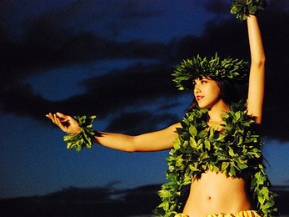

Live Music
Kihei is one of the livelier areas of Maui. There’s plenty happening when the sun goes down. The most popular spot for locals and tourists is nicknamed Triangle. Eight bars can be accessed in one area.

Life’s a Beach stands in front and offers nightly entertainment including pool table, bar food, a full bar and draft specials.
Ambrosia Martini Lounge the smallest venue also with nightly entertainment and an outside bathroom (key needed).
Kahale’s Beach Club is a little more laid back, less expensive, and more frequented by locals. The live music is usually a band playing Hawaiian music, and they serve a limited selection of appetizers and burgers.
Dog and Duck Irish Pub select entertainment with participating game nights, live music and inside and outside service.
The Tiki Lounge fills up on the weekends with its house music, DJ's and local bands. Small bar area with better seating outside with waitress service.

Restaurants
Return to table of contents

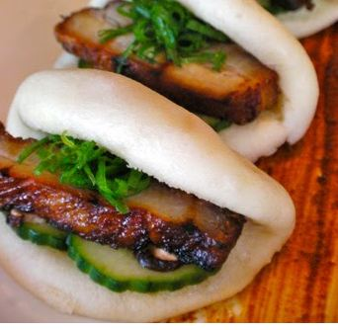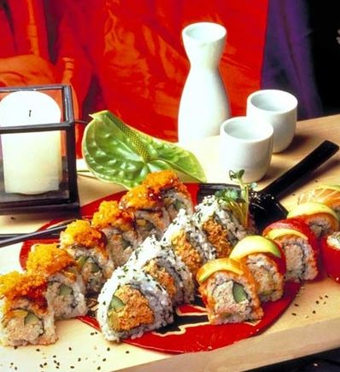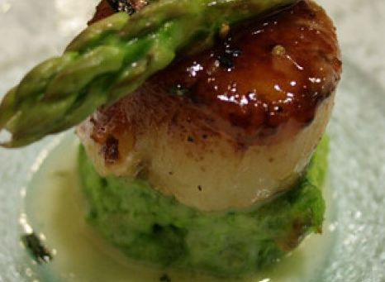

Local Dining Opportunities

Within walking distance:

Freds Mexican Café Complex -2511 S Kihei Rd
Fred's Mexican Cafe (808) 891-8600 fredsmexicancafe.com Amazingly tender fajitas with a beautiful sunset view. Also serves breakfast!
Moose McGillycuddy's (808) 891-8600 Relaxed outfit with a lanai & ocean views featuring a big menu of pub grub plus happy hour specials.

Kamole Shopping Center -2463 S Kihei Rd
Coconut's Fish Cafe (808) 875-9979 http://coconutsfishcafe.com
Delicious fish tacos! Their mango salsa is to die for! These wonderful fish tacos are also gluten-free.
The Cinnamon Roll Place Made from scratch cinnamon rolls, scones and banana bread
Kihai Aloha Ice cream- 808-879-0189

Rainbow Mall-2439 S. Kihei Rd
Café O’Lei: (808) 891-1368 http://www.cafeoleirestaurants.com/

Maui Thai (808) 874-5605 http://www.mauithaibistro.com/ Thai, Asian, Fusion / Eclectic
Da Kitchen Express Breakfasts, fish tempura, teriyaki beef & a signature chicken katsu in a simple, casual space.
S&Q's Coffee and Shave Ice Shack (808) 344-6598 Fresh made waffles, breakfast sandwiches and of course shaved ice and coffee

Beachside
Sarento's On the Beach 2980 S Kihei Rd, Kihei (808) 875-7555 http://sarentosonthebeach.com/ Fine dining on the beach
5 Palms Restaurant 2960 S Kihei Rd (808) 879-2607 Oceanside eatery & patio for crab cakes, sushi, BBQ ribs & cocktails in a polished, open-air space.

Dolphin plaza- 2395 S Kihei Rd
Maui Fish'n Chips 2395 S Kihei Rd #110 (808) 757-8708 http://www.mauifnc.com/
Serving Fish and chips and Teryaki
Cafe @ La Plage 2395 S Kihei Rd (808) 875-7668 http://www.cafealaplage.com/
Cozy Internet cafe in an oceanside strip-mall featuring sandwiches, bagels & soups, plus free WiFi.
Koiso Sushi Bar 808-875-8258
Yummy sushi served in a small location. Reservations needed as they are normally booked out at least a week.

Maui Tacos 2411 S Kihei Rd, Kihei (808) 879-5005 http://mauitacos.com/
Chain restaurant with good cheap tacos

Food trucks on Alanui Ke’ali’i
Aloha Thai Fusion (808) 268-7018 Food truck serving Asian fusion
Kinaole Grill Food Truck- (808) 280-9048 Food truck serving grilled shrimp, seared ahi and delicious lilikoi cheesecake

A little further out (10 minute drive):

Shaka Plaza Complex
1770 S. Kihei Rd (intersection of Kupuna St. & Kihei Rd)
Shaka Pizza (808) 874-0331 http://www.shakapizza.com/
Memphis Belle Coffee (808) 868-4091 http://www.memphisbellecoffee.com/
Kukui Mall
1819 South Kihei Rd
Starbucks (808) 891-0903 http://www.starbucks.com/
Stewz Maui Burgers (also known as Stewart’s Burger) (808) 879-0497 http://stewzmauiburgers.com/. This burger place is fantastic!
Thailand Cuisine (808) 875-0839 http://www.thaliandcuisinemaui.net/
Tutti Frutti (808) 891-8098 http://www.tuttifruttimaui.com/
Momma Ribs & Rotisserie (808) 875-7755 http://mamasribsmaui.com. This is more of a take-out place.

Pita Paradise 34 Wailea Ike Dr, Kihei,808-875-7679 http://www.pitaparadisehawaii.com/
Mediterranean and Vegetarian menu. Try the baklava ice cream.
Monkeypod Kitchen 10 Wailea Gateway Pl,Kihei (808) 891-2322 monkeypodkitchen.com Monkeypod Kitchen by Merriman is a place where foodies, beer lovers, and families escape the stresses of their day-to-day lives by enjoying an ice-cold beer and a great meal

Kihei Town Center 1881 South Kihei Rd (near Foodland)
Sansei Seafood Suite 116 (808) 879-0004 http://www.sanseihawaii.com
Sushi restaurant featuring lots of specialty rolls. They usually offer 50% off between 5-6 on Sunday and Monday (Get there early as there is always a line) and after 10 pm- Call for details.
Cuatro Restaurant Suite 3 (808) 879-1110 http://www.cuatro808.com/
Asian\Latin fusion. One of the top restaurants on tripadvisor in Kihei They offer 20% off if eating before 6 pm and their food is delicious. If you want wine or beer, you will need to bring your own bottle. They charge a $7 corkage fee. The ahi nachos and the pupu steak are our favorites. Reservations recommended.

Kihei Kalama Village 1913 – 1945 South Kihei Rd
Three's Bar and Grill 1945 S Kihei Road, Kihei (808) 879-3133 http://threesbarandgrill.com/
Try the Macadamia nut encrusted chicken breast. Best happy hour on Maui. $3 drinks and half price appetizers. Live music on the deck.
Paia Fish Market (808)-874-8888 https://paiafishmarket.com/ Great seafood!
The Dog and Duck Irish Pub (808) 875-9699
Fat Daddy’s Smokehouse BBQ (808) 879-8711 http://www.fatdaddysmaui.com/
South Shore Tiki Lounge (808)-874-6444 http://www.southshoretikilounge.com/ Cheap drinks and fun atmosphere
What Ales You (808)-214-6581 http://whatalesyoumaui.com/ Gastropub featuring craft beers, pork tacos, burgers and live music.
Horhitos Taqueria (808) 298-5670. Taco truck with cheap fish tacos.
Kihei Caffe (808) 879 2230 http://www.kiheicaffe.net
Popular restaurant for breakfast. There is almost always a line in the morning after 8am.
Lava Java Coffee Roasters (808) 879-1919 http://lavajavamaui.com/
Wonderful coffee and fresh pastries.
Pupu Lounge Seafood & Grill Suite D (808) 875-4111
Rita’s Finest Steak & Fish House (808) 214-5788 http://www.ritasmaui.com

A little further out (20 -45 minute drive)
Star Noodle 1285 Front St, Lahaina (808) 667-5400 http://www.starnoodle.com
Our favorite restaurant in Lahaina. The food is reasonably priced and delicious.
Mala Ocean Tavern: 1307 Front St, Lahaina (808) 667-9394 http://www.malaoceantavern.com
Beautiful location, right on the water. Their ahi bruschetta is absolutely delicious. Reservations recommended, try to get out on the deck if you can.
Tin Roof Maui 360 Papa Pl y, Kahului (808) 868-0753 http://www.tinroofmaui.com/ TINROOF is a new generation mom & pop shop, owned by Internationally recognized Chef Sheldon Simeon & his wife, Janice.

Food Truck across from Costco in Kahului
An amazing diversity of great flavors and island style favorites... fresh fish, plate lunches, noodles, chicken, shrimps, tacos, curry, fries, sushi, coffee, cold drinks and so much more. There's a nice big shady area with lots of picnic tables and trash/recycling cans, and room for everyone. Buy your lunch and find a spot to sit.
Most days you'll have a selection of 6 or more food vendors including:
- Thai Mee Up
- Kalei’s Lunch box- the brussel sprouts are so good
- Wayne’s Sushi
- Like Poke -Amazing Poke featured on Diners Drive Ins and Dives
- Mo’Ono Hawaii
- Maui 8 Wonder Tacos- delicious tacos

Leave room for Dessert
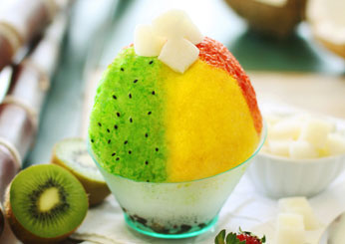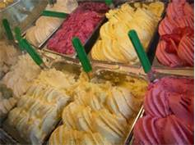

Local Boy Snack Shop (808) 344-9779 http://www.localboysshaveice.com/ Located in the front of the International Open Air Market place. Wonderful shave ice!

Ululanis 61 S Kihei Rd, Kihei http://ululanisshaveice.com/
A must try when visiting the island. Not all shaved ice is created equal.

Ono Gelato 1280 South Kihei Rd, #101A, Kihei (808) 495-0287
The coconut gelato is my personal favorite!

Leoda’s Kitchen and Pie shop 820 Olowalu Village Rd., Lahaina (808) 662-3600
(On the way to Lahaina) Fresh made mini pies made daily.

