Guide to Maui
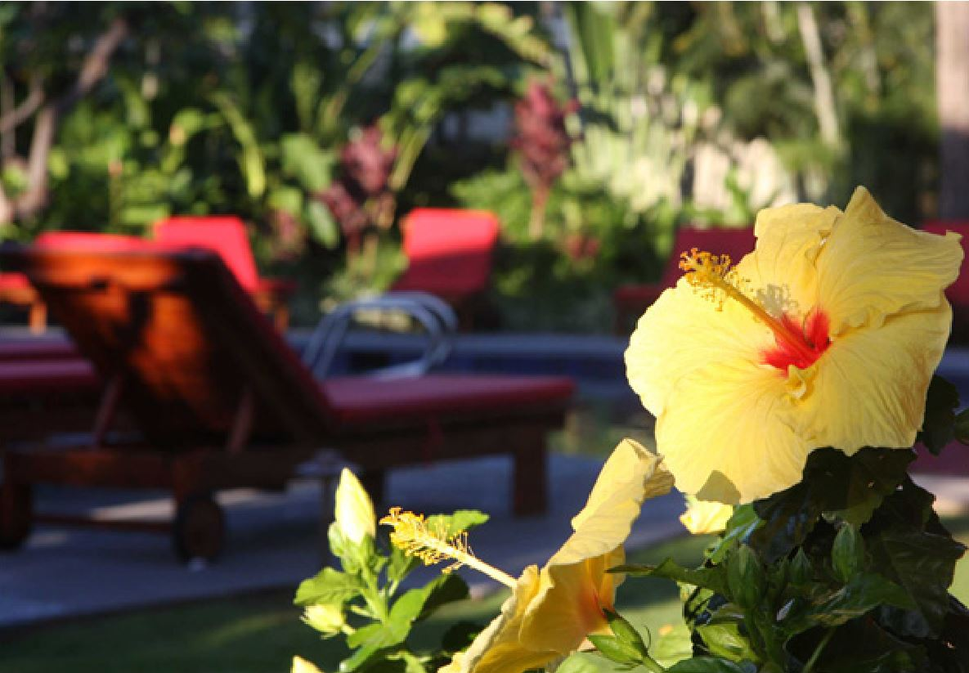
Thank you for choosing to stay in our condo in Lahaina. We love Maui and have put together this guide to share some of the things we love best with you.
Enjoy!

The Ritscher-Osorio Family
www.mauiparadiserentals.com

Table of Contents:
- Contact Information
- Transportation
- The Island
- Things to do in Kihei and Maui
- Beaches
- Shopping
- Nightlife
- Restaurants

Contact Information
Return to table of contents

We hope you enjoy our little piece of paradise as much as we do. When you arrive, please take a moment to look over the condo and let us know if anything is not to your satisfaction. Please also take a moment to look through this binder which includes useful information about the resort and the area. Please keep in mind this is a privately owned condo and the front desk will not be able to assist you doing your stay. We can be reached by phone or email at any time if you need anything during your stay.

Please call or text us at:
1-206-949-5758 or 1-206-949-5769

Or email us at:
Info@MauiParadiseRentals.com

Follow us on these social networks for updates:
Facebook - https://www.facebook.com/LahainaRental
Twitter - https://twitter.com/LahainaRental
Pinterest - http://www.pinterest.com/lahainarental/

Parking
The parking lot at Aina Nalu is owned and managed by a separate company. If you will be parking on-site, you will need to pay for a parking pass at the front desk ($20/day as of November 2020) and keep it in your car for the duration of your stay.
There is some street parking available at no charge as well as cheaper parking ($12 for 24 hours) across the street at Republic parking.
If you'd like to avoid the parking fee, we encourage guests to try the free street parking and if it proves difficult, then pay for the remainder of the stay either at the resort or across the street. The front desk requires that you pay for the full remainder of your stay (you're not able to pay for one night and not the next).

Transportation
Return to table of contents
Renting a car
All the major rental car companies are near the airport. Advantage Rent a Car http://www.advantage.com/ is normally the most cost effective rental.

Most of the rental car agencies also have locations in Lahaina (Avis, Dollar, Enterprise, etc.)

Taxi Services
CB Taxi (808) 243-TAXI (808) 243-8294
Serving: Wailea, Kihei, Wailuku, Kahalui, Paia, Makawao, Haiku, Lahaina, Kaanapali, AIRPORT, and ALL of Maui
Available 7 Days a Week/24 Hours a Day
Visa & Master Card Credit Cards accepted
http://cbtaximaui.com/

Lahaina Taxi (808) 661-5959
Serving: ALL of Maui
Email: lahainataxi@yahoo.com
Credit Cards accepted
Star Maui Limousine (877) 875-6900 (808) 875-6900
http://www.limohawaii.com/
Email: info@limohawaii.com

Shuttle Services
Maui Airport Taxi and Shuttle (808)877-2022
http://mauiairporttaxi-shuttle.com/

Speedi Shuttle (877)242-5777
http://www.speedishuttle.com/

Roberts Shuttle (808) 439-8800
https://www.robertshawaii.com/airport-shuttle/maui/

Public Bus Transit System
Maui Bus Service (808) 871-4838

Website: http://www.co.maui.hi.us/index.aspx?NID=1310
(Bus times and routes)

Fees - Effective July 1, 2017 (Check for latest fare information.)
The fare is $2.00 per boarding. Daily and monthly passes are also available.
Daily Pass $4.00.
No transfers are given on any of the routes.
The Maui Bus public transit service consists of thirteen (13) bus routes, all operated by Roberts Hawaii. These routes are funded by the County of Maui and provide service in and between various Central, South, West, Haiku, Kula and Upcountry Maui communities.
All the routes are operated seven days a week, including all holidays. No transfers are given on any of the routes. All vehicles on the routes are ADA accessible.
NOTE: The closest bus stop from the condo is at The Wharf Cinema. Take Hale Street which is directly across the entrance from Aina Nalu and walk down the safe alley. This walk will lead you to Front Street.
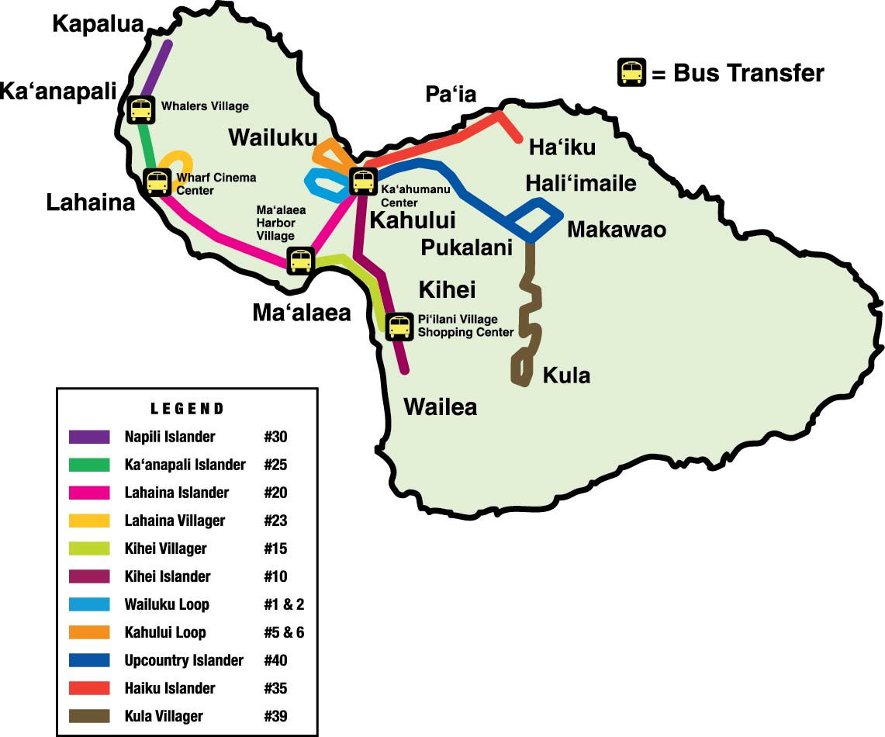

Lahaina Area Map

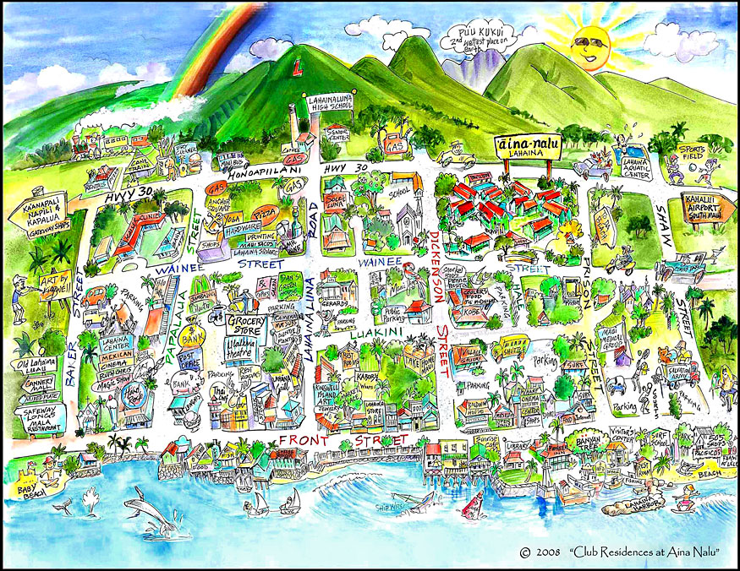

Aina Nalu Resort Map

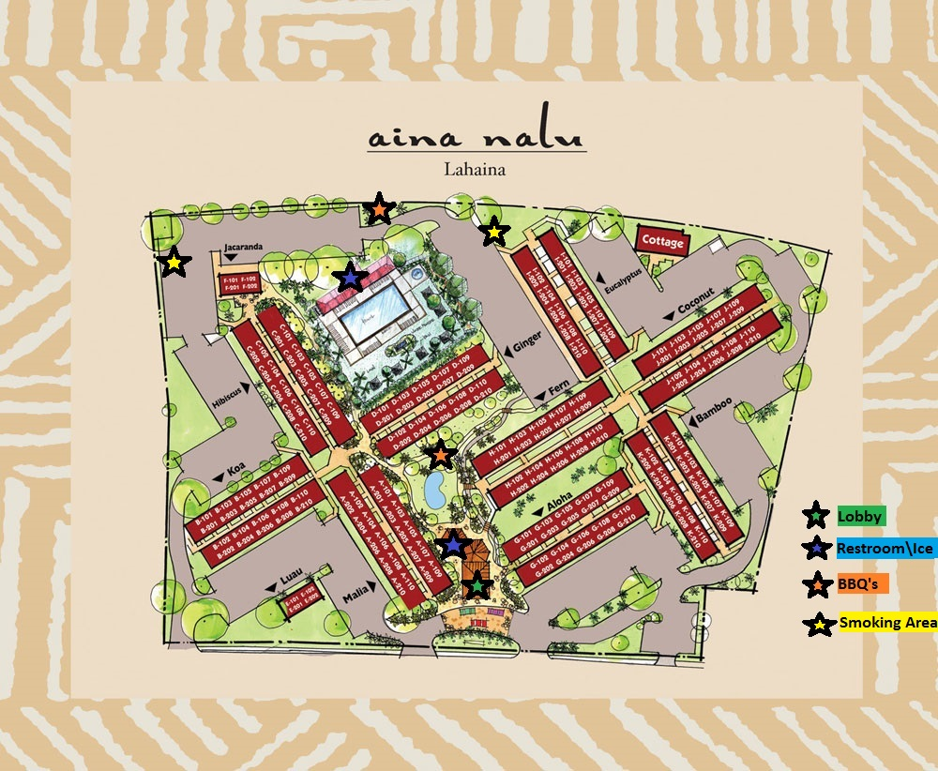

The Island
Return to table of contents

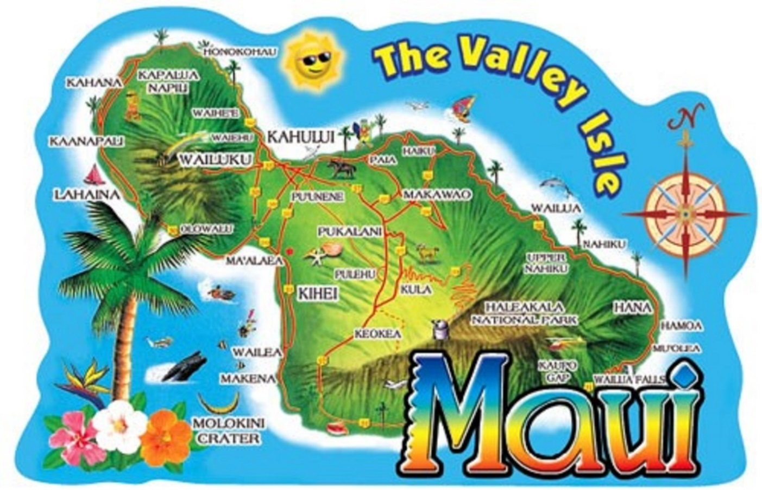

Legends say the demigod Maui pulled the Hawaiian Islands from the sea and lassoed the sun atop Haleakala, the island’s highest peak. The island of Maui was named after this mythological being, perhaps because the shape of the island is said to resemble his head and body.
King Piilani was the first ruler to unite all of Maui under a single family of alii (royalty) in the early 15th century. In 1790, King Kamehameha I defeated Kahekili, Maui’s last king, after a fierce battle in the iconic Iao Valley. Kamehameha took control of Maui and made Lahaina the new capital of the unified Hawaiian Kingdom. For nearly five decades, Lahaina served as the center of government for Hawaii. Simultaneously, the town experienced a surge in its whaling industry. At the height of the whaling era (1840-1865) as many as 500 ships anchored in Lahaina’s port.
Maui’s first sugar mill began operations in 1828. As the sugar industry in the islands grew, an influx of plantation workers from China, Japan, Puerto Rico, Korea, the Philippines, Portugal and Europe arrived in Hawaii. These immigrants became the foundation of the multi-ethnic culture of Hawaii today. You can experience these influences at places like the Lahaina Jodo Mission and in the fusion of flavors found in Hawaii Regional Cuisine.
The Lahaina Historic Trail and other notable attractions allow you to explore Maui’s rich past today, adding a fascinating new dimension to your visit.
www.gohawaii.com/maui/about/history
Central Maui
Home to much of the island’s population, this area offers plenty of interesting attractions and off-the-beaten-path treasures to uncover. The top attraction in Central Maui is peaceful Iao Valley State Park, with fog-shrouded forests, lush valleys and burbling streams. Take an easy hike on a paved trail to view one of Maui’s most iconic landmarks, the 1,200-foot Iao Needle. At the gateway to Iao Valley State Park, you can browse local shops, restaurants and historic sites in the charming town of Wailuku. The neighboring town of Kahului is a bustling shopping district with Maui’s largest mall, and if you want to stock up for an epic trip, everything you need can be found here.
East Maui
When your mind imagines Maui, it probably looks a lot like the island’s epic east side: cascading waterfall pools hidden in lush rainforests, roadside pineapple stands, hairpin turns around plunging sea cliffs. It’s all here, along the legendary Road to Hana—one big reason why East Maui is a must-see on any traveler’s list.
South Maui
You’ll find the sunniest, driest area of Maui on the peaceful southwestern coast. Blessed with miles of sandy beaches and clear views of the islands of Lanai, Molokini and Kahoolawe, South Maui is a place for lazy days and romantic nights. Explore the immersive underwater aquarium at the Maui Ocean Center in the whale-friendly Maalaea Bay. Golf at world-class courses in Wailea. Shop and dine in some of Maui’s finest restaurants and resorts. Discover Maui’s warm hospitality on its spectacular southern coast.
West Maui
The sunny northwest coast of Maui was once a retreat for Hawaiian royalty and the capitol of the Hawaiian Kingdom. Today, West Maui is home to spectacular resorts, shopping, restaurants, a wealth of activities and some of the most amazing sunsets in the world. Traveling north from Maalaea and the Maui Ocean Center, your first stop is the historic whaling town of Lahaina. Rustic buildings recall its days as Hawaii’s busiest port while bustling shops on Front Street and winter whale watching make it a favorite port of call for cruise ship passengers. A few minutes more on the Highway and you’ll find yourself drawn into the vibrant Whalers village. Whether you’re staying in the area or just passing through, a stroll on the Kaanapali Beachwalk is always in order. Families play on the beach, shoppers buzz in and out, and diners sit back and simply soak in the view. Further up is Kapalua, known for championship golf and private getaways. Here, the tone is a bit quieter, with understated elegance.
Upcountry Maui
Golden beaches give way to rolling hills and misty mountains as you ascend into Upcountry Maui, which is located on the higher elevations surrounding Haleakala — the island’s highest peak. Since early times, Hawaiians have farmed the volcanic soil of Upcountry fields, growing taro and sweet potato. Today, you can take farm tours, visit a goat dairy or even sip Maui-made wines and spirits in the rustic outposts of Kula, Makawao and Paia.

Beaches
Return to table of contents

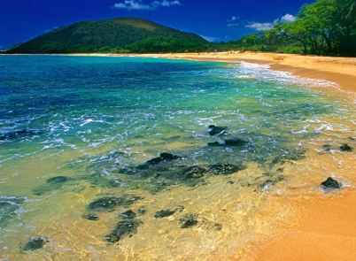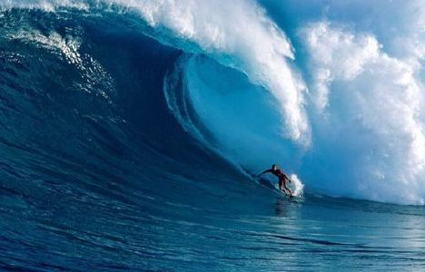

Within walking distance

Baby Beach (Puunoa Beach)
Baby Beach has much calmer waters than most other beaches because an offshore breakwater blocks many of the big waves from reaching the shore. This beach is a good place for children to go in the ocean with adult supervision.

Baby Beach is in the north part of Lahaina. Visitors can park on Kai Pali Street in a dirt lot, just off Front Street or walk from the unit (about ¾ of a mile- Walk north on Front, turn left on Kamaka circle and look for shoreline access on the left).

505 Beach (Kamehamehe Iki) :
This stretch of sand is named after the street address of the shopping plaza that sits on the south side of Lahaina. 505 Beach extends from the fishing wharf, where most of Lahaina's boats harbor, down to the south end of the 505 shops. 505 Beach is a great place to learn how to surf.

Lahaina Beach:
You can snorkel, scuba dive and surf at the end of the harbor from this rocky beach along Front Street. Not much for swimming. South of this beach is "Shark Pit" and to the right is the "Breakwall” which is the most popular and sometimes over-crowded beginner surf breaks on the island.

A little further out

Ka’anapali Beach:
Beautiful golden sand and crystal-clear water make this a very popular beach. One of Maui’s best beaches is Kaanapali Beach, with three miles of sandy shores to enjoy. The northernmost section of the beach is a great place for snorkeling where you can see the different creatures living in the area up close and personal.
As one of the signatures of Kaanapali, cliff-divers love to jump off the beach’s northernmost edge, Puu Kekaa, or Black Rock. The ceremony occurs every evening at sunset to honor King Kahekili. Watch divers light the torches on top of the cliffs before they leap into the waters below. It is a spectacle you won’t want to miss!
Parking is expensive but your cheapest option is typically Whalers village. You can also take the bus and not worry about parking. Black Rock is located in front of the Sheraton Resort.

DT Fleming Beach Park
Voted best beach in America in 2006. Facilities include picnic tables, restrooms, showers and lifeguards. The beach backs up to a grove of trees providing much needed shade. Visitors can sunbathe, swimming, surfing, and boogie boarding. Surf and wave conditions are posted on a dry erase board at the lifeguard shack on the beach.

Fleming Beach is near the Ritz Carlton hotel at Kapalua. Drive up north of Kaanapali on highway 30. Turn at the green sign for Lower Honoaiilani Road between Mile Markers 31 and 32.

Kahana Beach
If you’ve ever had an interest in windsurfing, Kahana Beach is the place for you, as if offers excellent windsurfing conditions. There are lifeguards on duty, so safety won’t be an issue. The beach also features convenient restrooms and showers for a quick change as well as picnic tables, so you can enjoy a meal as you gaze out onto the ocean.

Ho'okipa Beach, North Maui
The best place in the world to watch windsurfers is known as the "windsurfing capital of the world." You'll also see some great board surfing here towards the east end of the beach. Ho'okipa Beach is also a great place to see turtles coming up on the beach (this is not in any of the guide books). They start coming up approximately 1 hour before sunset. The gate closes at 7pm, so make sure you leave the park by then.

Kamaole Beach Parks I, II, & III:
Ample parking, lifeguards, volleyball courts and excellent swimming conditions make the Kamaole Parks in Kihei a local favorite.

Makena Beach State Park (Big Beach):
One of Maui's signature spots is at the top of the list of beaches not to miss. With white sands extending nearly 2/3 of a mile long, Makena Beach is one of the largest beaches in Maui. Boogie boarding is very fun at this beach, but the waves can get a little big in the late afternoon.

Wailea Beach
Wailea Beach is located toward the southernmost part of Kihei. It is a large beach, crescent in shape, capped on either point by black, lava rock formations. This lends to the calmness of the waters, making this an ideal place for swimming, snorkeling, and sunbathing. Changing rooms, showers, eateries, and places to rent gear and equipment are available. There are lifeguards on duty. You will also find a large paved walkway leading to a variety hotels, restaurants, shopping and entertainment.

Keawakapu Beach
Situated between Kihei and Wailea to the south, Keawakapu Beach is one of the most picturesque stretches of coast in southwest Maui. This beach is rarely ever overcrowded, as there are no major resorts or hotels. The surf is always calm and the white sand and shady palms make the deal even sweeter. There are no lifeguards on duty, but you can find some places to rent equipment like umbrellas and chairs nearby.

Hana Beach Park
For a terrific family-friendly beach day, you won’t want to miss out on Hana Beach Park. This is another one of the most popular swimming beaches on the island. There are also many local community events held at this beach, so check one out to see how the locals enjoy themselves.

Kaihalulu Beach
Maui’s red stretch of beach sand. It was the site of a fortress and temple and birthplace of civil leader Queen Ka’ahumanu. Kaihalulu is one of the new red sand beaches in the world, made so by the abundance of iron, and with the rich contrast against the blue waters.

Snorkeling
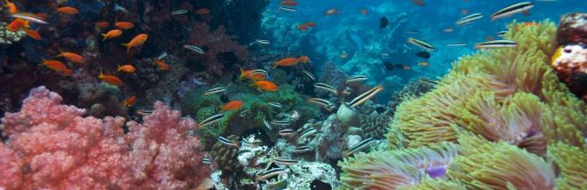
There are many great snorkeling places on Maui Ask for a free snorkel map at Maui Dive Shop or call them at 1-800-542-3483, or check out their web site at www.mauidiveshop.com.

Some of our favorites are:
Honolua Bay
Located about twenty minutes North of Lahaina Town on Maui’s North-West Shore. It’s one of the most incredible locations on Maui, Visibility can vary throughout the day depending on how much rain we have had. It can be pretty calm in this bay even when the trade winds are blowing up a snot out along the coastline. So if you cannot snorkel anywhere else because of wind and waves, this snorkeling Honolua Bay is a good bet.

Kapalua Bay
A calm sheltered cove, ideal for snorkeling. Kapalua is a nice sandy beach, though steep at times. Barefoot entry is easy, just keep your eyes open for the occasional rock in the sand. Snorkeling is best on the right side

Baby Beach
Has surprisingly good snorkeling at the far west end. It is very shallow and has gentle waves. We have seen turtles, squid and tons of fish here.

Black Rock
Located on Ka’anapali Beach in West Maui, and has won numerous awards as one of the best places to go in Maui

Ulua
Located between the Renaissance and the Wailea Marriott, both Ulua and Mokapu are popular places to snorkel and shore dive. This is a wonderful beach for snorkeling (one of our favorites) and diving when it is calm and just for hanging out. It is easy sandy beach for good access especially with children. Snorkeling is best at the right (north) side of the beach near the rocky outcrop. Swimming and snorkeling are best in the mornings (afternoons can be windy here, making the ocean choppy and the visibility poor). When surf is up, beach attracts body boarders. This is Maui's South shore training area for many scuba school's beginner dives. There are two reefs found stringed between the two beaches. The first one is great for snorkeling, and scuba divers best access the second one. The second reef is deeper and has a turtle cleaning station. Backed by a small park, ideal for picnics. Arrive early, parking lot fills up quickly.

Makena Landing
Makena landing, aka Five Caves aka Five Graves, is a wonderful spot to snorkel or dive. The topography here is diverse and sea caves plenty. This area is home to many small harmless reef sharks. Make sure to only snorkel here if there have been no rains or large surf due to the impairment of visibility. This area has plenty of parking and many entrance points.

Turtle Town Maui & Maluaka Beach
Turtle Town is at Maluaka Beach about 20 minutes south of Kihei. Maluaka Beach is easily one of Maui’s best-kept secrets and certainly a hidden gem for snorkeling. This is the best spot to see turtles on the island with virtually no crowds. Just remember: look, but don’t touch. These turtles are an endangered species

Ahihi Keanau Reserve
Ahihi Keanau Reserve is located in Makena and one of the more serene and beautiful spots on the island. Parking is a challenge in this area though. The road is narrow which has only a few openings for a car. The reef is shallow and perfect for snorkeling. This isn't the best Maui scuba diving location because it's so shallow; you'd rather be snorkeling unless you travel far out. The coral here is plentiful and comes in many brilliant colors. Keep in mind that this is reserve, which is why there are so many fish here. The fish are protected! If you want to do some Wailea fishing, charter a boat and stay out of this area.

Things to do in Lahaina and Maui
Return to table of contents

Lahaina Town and Banyan Tree
Lahaina is a cute little walking town with tons of shops and restaurants along Front Street. The Banyan tree was planted in April 1873 and now covers almost an acre! On Saturday mornings, local artists set up stands under the tree to showcase their wares.

Lahaina Art Walk
Every Friday night from 7 pm-10 pm dozens of art galleries along Front Street showcase their art along with wine and appetizers. Lahaina has earned its nick-name of "The Art Capital of the Pacific," due to more art galleries per capita than any other American town. A walking map of participating galleries is available at the Lahaina Visitor Center (open daily from 9 am to 5 pm).

One of the great benefits of this area, you can walk home

Maui Friday Town Parties
Maui Friday Town Parties is an initiative to showcase our island’s historic towns and celebrate the unique nature of the businesses in the communities. From Market Street to Front Street, from Baldwin Avenue to South Kīhei Road most every Friday our community gathers to celebrate art, music and Maui culture. Residents and visitors enjoy a special night of interaction and fun, punctuated with free entertainment, special offerings and Friday-only promotions from each town’s family of merchants.
What is the Maui Friday Town Party schedule?
- First Friday of the month – Wailuku
- Second Friday – Lahaina
- Third Friday – Makawao
- Fourth Friday – Kihei

What can I expect at a Maui Friday Town Party? Generally, from 6-9pm, Maui Friday Town Parties are a safe, fun community-minded way for both residents and visitors to kick-off the weekend under the stars and enjoy our small-town ambiance. Many retailers, galleries and boutiques operate extended hours and highlight special promotions. Crafters, artisans and culinary wizards add their creativity to the event. Attendees have fun while simultaneously supporting our economy and revitalizing historic Maui that includes live music from local musicians.
Excursions
Whether you want to fish, cruise, snorkel, scuba or just sail around, a majority of the excursions on island depart from the Lahaina harbor which is just steps away from the condo. There are also excursions leaving from Makena and Maalaea. Most of the companies have booths set up in the harbor and you can shop around for prices. There are also quite a few timeshare companies that offer discounted excursions or meals if you sit through a timeshare sales appointment. If you don’t mind investing a few hours of your time and are good at saying “No”, this can be a good way to reduce the cost of some of the excursions. Keep in mind, most of the timeshare sellers, will give you more than one discounted excursion with each timeshare presentation.

You can also book excursions from the concierge down by the saltwater pool.

Whale Watching
The waters surrounding Maui are the stage for some of the best whale watching in the world. Each winter thousands of kohola (humpback whales) travel to Hawaii from colder waters to breed, calve and nurse their young. Although the first whale sightings will usually occur sometime in October, whale season officially runs from December 15-May 15. Since activity tapers towards the end of the season, however, most Maui whale watches stop running sometime towards the end of April. There are dozens of companies offering whale watching tours leaving from the Lahaina, but our favorite are the ones ran by the Pacific Whale foundation.
Surfing and standup paddle boarding
Maui Wave Riders 133 Prison St. Lahaina (808) 661-0003 www.mauiwaveriders.com
Goofy Foot Surf School 505 Front St. Shops Suite 123 Lahaina (808) 244-9283 http://www.goofyfootsurfschool.com/
Royal Hawaiian Surf Academy 113 Prison St. Lahaina (808) 276-7873 www.royalhawaiiansurfacademy.com

Yoga Classes
Island Spirit Yoga 840 Wainee St. Lahaina (808) 667-2111 www.islandspirityoga.com
Bikram Yoga 845 Wainee St Ste 204 Lahaina (808) 661-6828 www.bikramyogalahaina.net

Gyms
Body in Balance 142 Kupuohi St Building #2 Lahaina (808) 661-1116 www.bodybalancemaui.com
Lahaina Crossfit 219 Kupuohi St. #101 Lahaina (808) 286-9422 www.lahainacrossfit.com
Passion of Movement 2780 Kekaa Drive Lahaina (808) 757-2318 www.passionofmovement.com (located at Royal Lahaina Resort)

Tennis Courts
Lahaina Civic Center 1840 Honoapiilani Hwy Lahaina (808) 270-7230
Malu Ulu Olele Park Mokuhina Pl Lahaina (808) 270-7230
Kapalua Tennis Garden 100 Kapalua Drive Lahaina (808) 662-7730

Other
Lahaina Aquatic Center 245 Shaw St Lahaina (808) 661-7611 http://co.maui.hi.us/Directory.aspx?did=125
Maui Boat Rentals (808) 879-3721
www.maui-boat-rental.com
Email: reservations@maui-boat-rental.com
Day Trips
Road to Hana (Full Day)
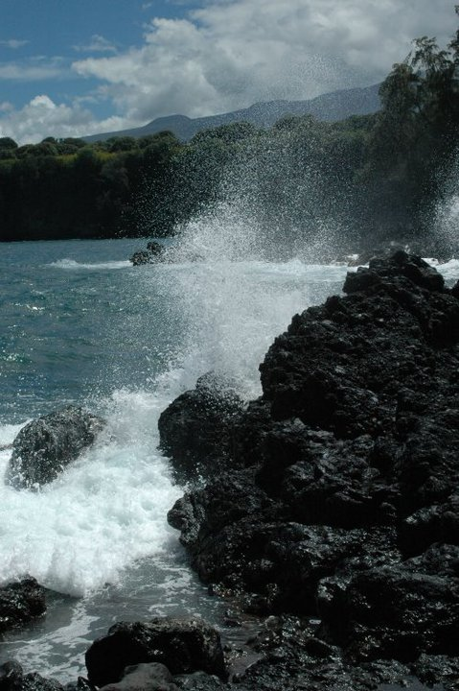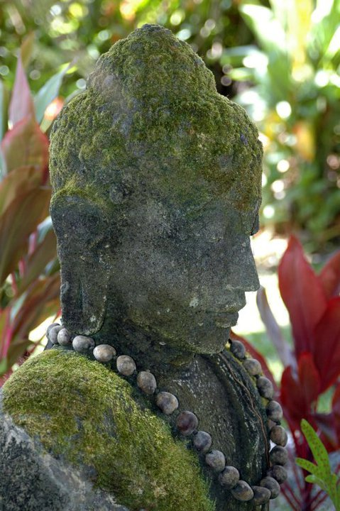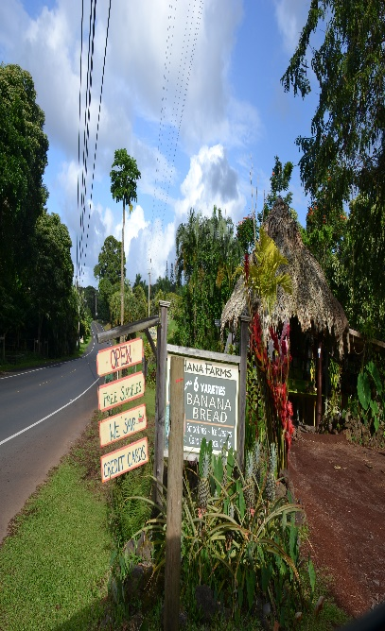
You can drive the road to Hana yourself, or take a tour in a van. It is a long and difficult drive on a narrow winding mountain road. If you prefer to have a tour van take you, you can sign up for a tour. Whether on your own or on a tour, you will see the gorgeous scenery of the rainforest, including many beautiful waterfalls of various shapes and sizes along the mountainsides. If you drive yourself, leave early (7 A.M) and take a picnic lunch. Allow six hours to get to Hana (with stops to see scenery), and three hours to return (without stops). It's 72 miles from the condo; the hard part (the Hana Road) has 617 curves and 56 one-lane bridges. If you are prone to motion sickness, do not read (not even the map) in your car or tour van. If you drive to Hana (rather than taking a van tour), be sure to take along the "Hana CD Guide. This is an audio CD that tells you what to see along the way. You play the CD in your car while you drive to Hana. You will see twice as many wonderful sights if you take this guide recording along plus the narrators are pretty entertaining.
Paia is the last town that you will pass before your make your journey to Hana. It is a great place to eat breakfast, grab some coffee or pick up a Hana picnic boxed lunch. Our favorite place is the one on the left, next to the bike shop. It is also a good idea to stop and use the restroom here as there are few restrooms along the rest of the route.

At mile marker 2, Twin falls is the first waterfalls along the Road to Hana with easy access. There is a farm stand selling yummy smoothies and there will be a bunch of parked cars. The hike to see Twin Falls is unique and beautiful. These picturesque waterfalls offer a large area to swim at. Consider sticking to the closest falls along the path (lower falls) to save time on your trip and be really careful of flash floods!

From the bluff, Ho'okipa (at mile marker 9) is a great spot to stop and watch some of the best surfing in Maui. In the winter, the waves can get pretty massive. Maui is Mecca to windsurfers and Kiteboarders due to consistent wind. DO NOT SURF HERE unless you are very experienced and are able to go with a local. At mile marker 9.5 there is Waikamoi Ridge Trial which has 2 hiking loops. One takes about 10 minutes and the other takes about half an hour. Waikamoi Trail can sometimes be muddy, but it's a pretty hike through the trees.

Remember the beauty of the road to Hana is the route itself, not the destination. Make sure you stop to enjoy the scenery and take lots of photos! The Garden of Eden is a beautiful place to stop for a picnic and enjoy your boxed lunch. It’s located at mile marker 10.5. They are open 8 am-3 pm and the entrance fee is $15 dollars per person. It's worth paying to enjoy walking the grounds, which are immaculately kept up and offer all kinds of photo opportunities. Here you can see and 100-year-old mango tree, bamboo, ocean views and Puohokamoa Falls. You may recognize some of the views here as they were featured in Jurassic park!

At mile marker 12 is Kaumahina state waside park. There is a beautifual view of the North coast plus real bathrooms, which are a rarity on the road to Hana. There are also hiking trails through the forest.

On the way to Hana, just past Mile Marker 16, turn left at the sign to Keanae, for close-up views of waves on lava rocks. Stop near the end of that peninsula to pick up a couple loaves of the world’s best banana bread, at the Keanae Landing Fruit Stand.

At mile marker 19 you will find Upper Waikani Falls AKA 3 Bears, there's enough room for 2-3 cars, but it's a no parking zone. Once a few cars park, 6-7 more park behind it and take up most of the road becoming a hazard. There is, however, a turnout further up the road where you can park and walk down. The walk is a little hairy because there isn't a path.

At mile marker 22 is Pua’a Kaa State Park. This rest stop offers a quick hike to a waterfall and a freshwater pool as well as bathrooms and picnic area. A great place to stretch your legs and get a quick swim.

At mile marker 29 is Nahiku MarketPlace. This is a fun spot to pick up some gifts and have a great meal. They have some of the better kalua pork tacos we've ever had.

At around the 31 mile marker, you'll need to turn left on 'Ula'ino Road. Less than a 1/2 a mile on the left, there is a massive lava tube. Also, they have a garden maze that's fun to cruise through. Drive a bit further and on the right you'll see the National Tropical Botanical Gardens. They have the only accessible view of Pi'ilanihale Heiau, which is the largest Temple in Hawaii.

Despite its size, Hana is packed with plenty to do. Snorkel at the breathtaking black sand beach of Waianapanapa State Park, or swing by Hale Piilani, which is the state’s biggest temple. Bring the kids for a day of swimming and layin’ low at Hana Beach Park.

If you have extra time, you can drive another 40 minutes beyond Hana to the beautiful Pools of Ohe’o, also called Ohe’o Gulch and Palikea Stream. (This area was formerly called the Seven Sacred Pools). There are several lovely waterfalls cascading into the series of natural pools, working their way down the mountain slope. Our favorite thing to do is the hike up alongside the pools to the top. There is a beautiful bamboo forests along the way. It is approximately 2 hours round trip.
A little further beyond here is Charles Lindbergh’s grave at Palapalo Hoomau Church, but it is not visible from the road and is bit difficult to find.
Haleakala National Park
Haleakala (elevation 10,023 feet) is the mountain that makes up the entire east half of Maui. The crater at the top of this volcano is one of Maui’s most incredible sights. The view at the top of Haleakala is beautiful at any time of the day, so you don’t have to go only at sunrise but this is when most people go. You'll see the multicolored volcano crater (that last erupted in 1790) and the views of Maui's central valley. It is much colder at this elevation than at the beach, so bring a jacket.Park admission is $10 per car. Keep your receipt as you can use this to park at the bamboo forest too! Free ranger nature talks in the summit building are offered. The crater is seven and a half miles long, two and a half miles wide and 3000 feet deep. You will look down on the clouds, and see the "Big Island" of Hawaii in the distance across the ocean. (The left mountain is Mauna Kea 80 miles away, and the right mountain is Mauna Loa 100 miles away). We recommend leaving the condos by 3:30 a.m. It takes almost two hours to get there. Due to its popularity, you now need a reservation to see sunrise. For more info, go to
https://www.recreation.gov/tourParkDetail.do?contractCode=NRSO&parkId=147940

Botanical Gardens
Kepaniwai Heritage Gardens Park
Bring the whole family to Kepaniwai Heritage Gardens Park to learn about the island’s cultural and ethnic heritage. As you move through the park you’ll see a traditional Hawaiian hale, a New England-style missionary home, Japanese gardens with stone pagodas, a Filipino farmer’s hut and a Chinese pavillion with a statue of Sun Yat-sen, a revolutionary hero. You and your family can enjoy a lovely meal together in the park’s picnic area surrounded by natural beauty. The park also features the Hawaii Nature Center, where kids can experience exhibits geared toward them. The center also offers two-hour rainforest walks.
Arts, Cultural Centers, Museums
Whalers Village Museum
For a top-notch Humpback Whale education, stop at the Whalers Village Museum. Volunteers here can answer any questions about the animals. The 40-foot sperm whale skeleton located near the entrance is sure to impress, and it sets the scene for a trip inside in the museum. Learn about the history of whaling on the island and check out collection of harpoons, tools, sea chests, sailor journals and ship logs. Take a self-guided audio tour in many different languages as you look at artifacts, photo murals, movies and graphics depicting the life of sailors. You can even see a scale model of a whaling ship with an exact replica of the living quarters of a 25-member whaling crew.

Maui Arts and Cultural Center
To get a taste of Maui’s culture, head to the Maui Arts and Culture Center, a performing arts complex. Check out live music, an art exhibit or a variety of other events that celebrate creativity in its theaters, outdoor performance space, gallery concert stage and courtyard with bistro dining and food and beverage bars.

Maui Ocean Center (Aquarium) 192 Ma'alaea Rd, Wailuku (808) 270-7000
http://www.mauioceancenter.com

Wine Tasting
Tedeschi Vineyards Hwy 37, Kula, Maui (808)878-6058 www.mauiwine.com
Free tour of Maui's only winery and free wine tasting in Upcountry.
Open daily from 10 am to 5:30 p.m.

Vodka Sampling and Tours
Organic Ocean Vodka 4051 Omaopio Rd., Kula, Maui (808)877-0009 http://oceanvodka.com/
Open daily from 9:30 am to 5 p.m. Entrance is $10 a person
Tour times are every half hour, starting from 9:30 a.m.

Cheese tasting
Surfing Goat Dairy 3651 Omaopio Rd, Kula, HI
Surfing Goat Dairy is a dairy farm in Kula, Hawaii on the island of Maui. It produces more than two dozen goat cheeses. Many of the cheeses have won national awards. Tours are offered.

Local Golfing
15 minute drive
Royal Kaanapali Golf Course If you like to hit a round of golf, don’t miss the world-class courses at Royal Kaanapali, designed by Robert Trent Jones Sr., and Kaanapali Kai. Both offer pristine fairways and Bermuda grass on the greens, yet the 18th on the Royal can be a real doozy. Royal is often referred to as the Tournament Course, since it hosted the LPGA and Senior Tours during the 1980s.

35 minute drive
Pukalani Country Club 360 Pukalani Street, Pukalani (808) 572-1314
18 holes, par 72, 6882 yards. All prices per person and include golf cart rental.
Elleair Maui Golf Club (808) 874-0777
18 holes, par 71, 6801 yards. All prices per person and include golf cart rental.
1345 Piilani Highway, Kihei, HI 96753

45 minute drive
Makena Golf Course 5400 Makena Alanui, Wailea-Makena (808)891-4024
18 holes, par 72, 7017 yards. All prices per person and include golf cart rental.
Wailea Emerald & Gold Golf Club 100 Wailea Golf Club Drive, Wailea (808) 875-7450
18 holes, par 72, 6825 yards & 7078 yards. All prices per person and include golf cart rental.
Wailea Old Blue Golf Course 120 Kaukahi Street, Wailea (808) 879-2530
18 holes, par 72, 6765 yards. All prices per person and include golf cart rental.

Shopping
Return to table of contents
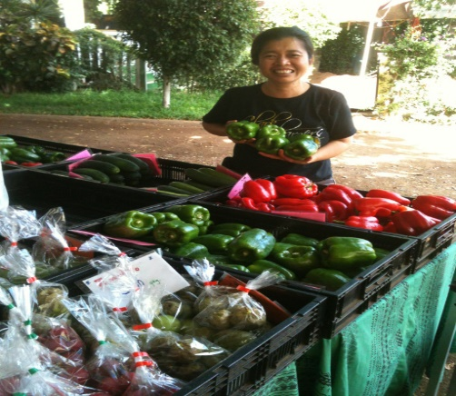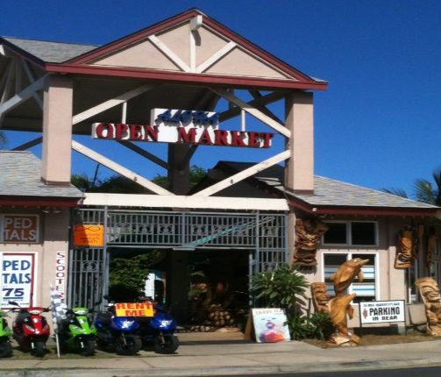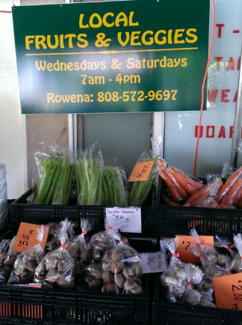

Food is very expensive on Maui. If you have a Costco membership, stop at Costco and stock up before heading to the condo. Alternatively, there is also a Target and Walmart near the airport.
Grocery Stores in Lahaina
Foodland 878 Front St · (808) 661-0975
Open from 6 am to 12 a.m. 1.5 blocks down Wainee St. It’s a 10 minute walk from the condo.
Take a right when exiting the resort. Walk down Wainee St and Foodland will be on your left.
Foodland Farms 345 Keawe St Suite 304· (808) 662-7088
Safeway 1221 Honoapiilani Hwy, Lahaina · (808) 667-4392
Located inside the Lahaina Cannery Mall
Aina Gourmet 130 Kai Malina Parkway Lahaina- 808-662-2832 http://ainagourmet.com/
Others Natural Food Markets around the island

(These are good places to find Organic and specialty foods like gluten free)

Mana Foods: 49 Baldwin Avenue, Paia.
http://manafoodsmaui.com/
One of our favorite grocery stores in Maui! The prices are reasonable, and they have a wide variety of specialty items. There deli and smoothies are amazing!
Down to Earth: Kahului http://www.downtoearth.org/our-stores/store-locations/kahului-maui
Whole Foods Market: Kahului
Pukalani Superette: Pukalani
Haiku Grocery: Haiku
Rodeo General Store: Makawao
Cash n Carry Warehouse: Kahului
Times Supermarket: Kihei

Farmers Markets (Fruit and Vegetable Stands)
West Maui (Lahaina-Kaanapali-Kapalua side):
Farmers' Market of Maui-Honokowai 3636 Lower Honoapiilani Rd, Honokowai
Monday Wednesday Friday, 7am-11am
Central Maui and Upcountry (Kahului-Wailea and Kula areas):
Maui Swap Meet Maui College in Kahului
Saturdays, 7am-1pm (A favorite of ours)
Kula Country Farms Kula Hwy at Kekaulike
Saturdays & Sundays, 11am-4pm
Upcountry Farmer's Market 55 Kiopaa in Pukalani
Saturdays, 7am-12 pm

South Maui (Kihei-Wailea side):
Farmers' Market of Maui-Kihei 61 Kihei Rd, Kihei
Monday thru Friday, 8 am -4pm

Lipoa Street Farmers Market 95 Lipoa St, Kihei
Saturdays 8 am-12 noon

Souvenirs
You are in the heart of Lahaina and only 1.5 blocks away from the best shopping area on the island for Souvenirs. Just head over to Front Street and walk in either direction. One of the best things about this area, you don’t have to hit all the shops in a single day since you can walk here every night.

Banyan Tree Saturday market
The Saturday market is fun and just a short walk away. Local artisans set up tables under the tree and sell their wares. They often have live music and food as well.

Nightlife
Return to table of contents

Luau’s (close to condo)
Old Lahaina Luau 1251 Front St, Lahaina (808) 667-1998
You can’t leave Maui without experiencing a traditional Hawaiian luau like the Old Lahaina Luau. You’re sure to feel the Hawaiian values of hookipa (hospitality) and pookela (excellence) as you enjoy a delicious fire-roasted feast. Reservation required.
Feast at Lele 505 Front St Ste 114, Lahaina (808) 667-5353
Offers a small, intimate up-scale luau in south Lahaina primarily attended by couples. Food is served table side instead of a buffet.
Royal Lahaina Luau 2780 Keka’a Drive, Ka’anapali, West Maui (866) 482 9775
Oceanfront Luau Gardens at Royal Lahaina Resort
Wailele Luau-Wailele Polnesian Luau 2365 Kaanapali Pkwy, Lahaina (866) 482 9775
The Westin Maui Resort & Spa
Maui Nui Luau at Black Rock, 2605 Kaanapali Pkwy, Lahaina (808) 661-0031
Sheraton Maui Resort & Spa

Luau’s (Further out-45 minute drive)
Te Au Moana Luau 3700 Wailea Alanui, Wailea 877-827-2740; http://www.teaumoana.com/
Wailea Beach Marriot Resort and Spa

The Grand Luau at Honuaula 3850 Wailea Alanui, Wailea 808-875-1234
The Grand Wailea

Live Music on Front Street:

Fleetwoods on Front Street: 744 Front St, Lahaina (808) 669-6425
http://www.fleetwoodsonfrontst.com/
The food is decent, but we normally just go up to the rooftop deck for live music and drinks.

Cheeseburger in Paradise: 811 Front St, Lahaina, HI 96761 (808) 661-4855
cheeseburgernation.com
You guessed it, cheeseburgers and other American food plus live music

Down The Hatch: 658 Front St, #102 (808) 661-4900
https://www.dthmaui.com/down-the-hatch/
Eat in their beautiful garden patio and enjoy some seafood with a southern flair. They have the longest happy hour of any restaurant on Maui from 2pm to 6pm. Try the Ahi Samurai or the Lava Lava Shrimp.

Captain Jack's Island Grill 672 Front St, Lahaina (808) 667-0988

Restaurants
Return to table of contents
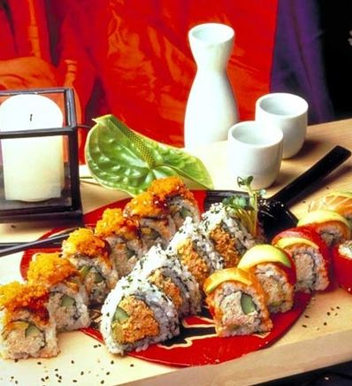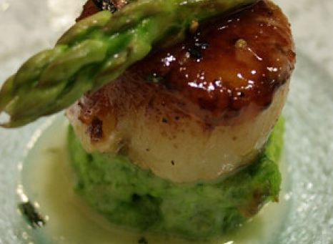

Local Dining Opportunities
There are easily over 50 restaurants within walking distance of our condo plus over 100 other restaurants within a short drive. Below are some of our favorites within walking distance

Star Noodle 1285 Front St, Lahaina (808) 667-5400
http://www.starnoodle.com
This one you will need to drive to, but it is our favorite restaurant in Lahaina. The food is reasonably priced and delicious. Sheldon from top chef used to be a chef here.

Penne Pasta Café:180 Dickenson Street Lahaina (808) 661-6633
Less than 5 minutes from the condo. The owner Juan is super nice and the food is quite yummy. The Penne Pasta Cafe menu offers a varied selection of pasta, unique thin crust pizza, sandwiches, garlic bread and daily specials at a reasonable price.

Paia Fish Market: 632 Front St, Lahaina (808) 662-3456
https://paiafishmarket.com/maui-restaurant/
Great fish tacos!

Lahaina Coolers:180 Dickenson Street Lahaina (808) 661-7082
http://www.lahainacoolers.com
Great outdoor patio and just around the corner from the condo.

Sale Pepe 878 Front St, Units 7 & 8 (808)667-7667
http://www.salepepemaui.com/
Great Italian food. It is a small place off the beaten path but has gotten pretty popular on the review sites, so it can fill up pretty quickly.

Fleetwoods on Front Street: 744 Front St, Lahaina (808) 669-6425
http://www.fleetwoodsonfrontst.com/
The food is decent but we normally just go up to the rooftop deck for live music and drinks.

Lahaina Grill:127 Lahainaluna Rd, Lahaina (808) 667-5117
http://www.lahainagrill.com
Voted one of the top 25 restaurants in the US for the last 4 years. Food is pretty pricey but it is delicious and the service is top notch!

Honu Seafood and Pizza: 1295 Front St. Lahaina (808) 667-9390
http://www.honumaui.com
Right on the water with amazing views. Prices are a bit high.

Mala Ocean Tavern: 1307 Front St, Lahaina (808) 667-9394
http://www.malaoceantavern.com
A beautiful location on the water. Their Ahi bruschetta is absolutely delicious. You can reserve a table on their website or over the phone.. Their view is amazing, and we highly recommend getting seating on their deck if you can snag a table.

Cool Cat Cafe: 658 Front Street Lahaina (808) 667-0908
http://www.coolcatcafe.com
Less than 10 minutes walk from our condos in Lahaina. The burgers are delicious and the décor fun. They often have live music at night

Kimo's Restaurant: 845 Front St, Lahaina (808) 661-4811
http://www.kimosmaui.com/
Great location right on the main drag with beautiful sunset views. Free hula pie with coupon found at http://www.mauileisureguide.com/coupons/kimos-restaurant-coupon.htm

Gerard’s Restaurant: 174 Lahainaluna Rd Lahaina, HI 96761 (808) 661-8939
http://gerardsmaui.com/
Fine dining at its best! Great place for a romantic dinner with that special someone. Prices are a bit high, but many people consider this the best fine dining experience on Maui.

Ono Tacos: 3510 Lower Honoapiilani Rd, Lahaina (808) 357-3779
Cheap and authentic street tacos. Excellent fish tacos for only $3

Pacific O Restaurant: 505 Front St, Lahaina (808) 667-4341
http://pacificomaui.com/
They use only locally grown produce and fish caught that morning.

Sansei Seafood restaurant and Sushi Bar: 600 Office Rd Lahaina (808) 669-6286
http://www.sanseihawaii.com
Sushi restaurant featuring lots of specialty rolls. They usually offer 50% off between 5-6 on Sunday and Monday (Get there early as there is always a line) and after 10 pm- Call for details

Pho Saigon 808 658 Front St Ste 145B (808) 661-6628
http://phosaigon808.com/
It's a good place to satisfy your pho and Vietnamese food craving
Short Drive Away:

Gazebo Restaurant:
5315 Lower Honoapiilani Rd, Lahaina
(808) 669-5621
Hours 7:30am – 2:00 PM
Tiny little gazebo with great breakfast food. There is almost always a wait so get here early! Make sure you take advantage of their free self-serve coffee while you wait. They also offer takeout if you don’t want to wait.

Hula Grill and Barefoot bar: 2435 Kaanapali Pkwy (808) 667-6636
http://www.hulagrillkaanapali.com
The best feature of this restaurant is sitting outside with your feet in the sand, enjoying the beautiful
views.

Teppanyaki 2 Go 3481 Lower Honoapiilani Rd (808) 866-4025
Food stand that is only open for between 5 and 8 pm Monday through Friday. Their Scallops are amazing!

Monkeypod Kitchen 2435 Kaanapali Pkwy (808) 878-6763
monkeypodkitchen.com
Located in Whalers village. The food is yummy and it can get very crowded. Not uncommon to have an hour long wait. Their pies are delicious

Further Out
Tin Roof 360 Papa Pl, Kahului, HI 96732 (808) 868-0753
tinroofmaui.com
Tin Roof Maui is a casual lunch shop by Chef Sheldon Simeon. My favorite dishes is their dry mein and pork bellies.
Mamas Fish House 799 Poho Pl, Paia, HI (808) 579-8488
Local landmark wins fans with its seafood-driven Hawaiian menu, Polynesian decor & epic ocean views
Café O lei at the Mill house: Located at the Maui plantation at m670 Honoapiilani Hwy #1, Wailuku, HI
The mill house used to be one of our favorite restaurants on Maui. We loved the food and the location is gorgeous, set on the old plantation. Unfortunately, due to Covid they closed, Café O’Lei has just opened a new location at the Mill house! We haven’t had a chance to try this location yet but the location is gorgeous and the food at the location in Kihei was good.

Food Trucks across from Costco in Kahalui
An amazing diversity of great flavors and island style favorites... fresh fish, plate lunches, noodles, chicken, shrimps, tacos, curry, fries, sushi, coffee, cold drinks and so much more. There's a nice big shady area with lots of picnic tables and trash/recycling cans, and room for everyone. Buy your lunch and find a spot to sit. Most days you'll have a selection of 6 or more food vendors

Leave room for Dessert:
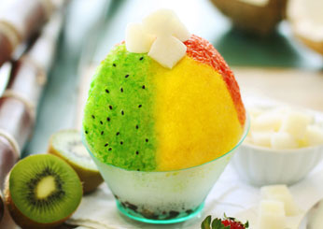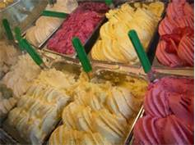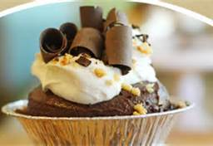

Ululanis: 819 Front Street, Lahaina (360) 606-2745
http://ululanisshaveice.com/
A must try when visiting the island. Not all shaved ice is created equal

Banyan tree treats 658 Wharf St, Suite 9, Lahaina, Maui
Ice cream and cookies

Ono Gelato: 815 Front Street, Lahaina (808) 495-0203
The coconut gelato is my personal favorite!

Leoda’s Kitchen and Pie Shop : 820 Olowalu Village Rd (808) 662-3600
They serve savory items as well, but their pies are amazing and made fresh They even serve mini ones so they are guilt free!

Sugar Beach Bake Shop 1 S Kihei Rd, Kihei, HI (808) 757-8285
From the fluffy cream puffs to the coconut cream pie and macadamia nut sticky buns, Sugar Beach Bake Shop is a must. The lilikoi key lime pie is the ideal mix of sweet and sour, and paired with a cup of fresh Maui coffee and a stroll on the beach directly across the street, the perfect way to start your morning in paradise.

Honolulu Cookie Company: 695 Front St. Lahaina (808) 667-7559
http://www.honolulucookie.com
The cookies are delicious and make great gifts to take home.

Monkeypod Kitchen 2435 Kaanapali Pkwy (808) 878-6763
monkeypodkitchen.com
Try the Strawberry cream pie!

